SLOVAK UNIVERSITY OF TECHNOLOGY IN BRATISLAVA

Faculty of Informatics and Information Technologies

Matej Pirschel, Monika Pinteková, Martin Pažický,   
Roman Berešík, Michaela Adamcová

**Eat not Meet**

Human Computer Interaction

Seminar: Monday 13:00

Seminar teacher: Miroslav Laco

Academic year: 2021/2022

**Contents**

**Initial Phase** **6**

Bad Design & Improvement Ideas 6

Web App Topic (brainstorming) 7

User Research 8

User-oriented Specification **9**

Personas **11**

User Scenarios 12

**Scenario 1 : Objednanie jedla neregistrovaným používateľom.** **12**

**Scenario 2: Objednanie obľúbeného jedla registrovaným používateľom.** **13**

**Scenario 3: Vytvorenie nového používateľského konta.** **14**

**Scenario 4: Spracovanie objednávky registrovaným kuriérom.** **15**

**Scenario 5: Registrácia nového kuriéra.** **16**

Information Architecture 17

**Návrh informačnej architektúry aplikácie Eat not Meet:** **18**

**Card sorting:** **19**

**Scenario 1: Objednanie jedla neregistrovaným používateľom.** **20**

**Scenario 2: Objednanie obľúbeného jedla registrovaným používateľom.** **20**

**Scenario 3: Vytvorenie nového používateľského konta.** **20**

**Scenario 4: Spracovanie objednávky registrovaným kuriérom.** **21**

**Scenario 5: Registrácia nového kuriéra.** **21**

**Prototyping Phase** **22**

2.1 Low-Fidelity Prototype (1st iteration) **22**

**Scenario 1: Objednanie jedla neregistrovaným používateľom.** **22**

**Scenario 2 : Objednanie obľúbeného jedla registrovaným používateľom.** **23**

**Scenario 3: Vytvorenie nového používateľského konta.** **25**

**Scenario 5: Registrácia nového kuriéra.** **26**

**Scenario 4: Spracovanie objednávky registrovaným kuriérom.** **27**

Low-Fidelity Prototype (2nd iteration) 28

**Scenario 1: Objednanie jedla neregistrovaným používateľom.** **28**

**Scenario 2 : Objednanie obľúbeného jedla registrovaným používateľom** **30**

**Scenario 3: Vytvorenie nového používateľského konta.** **32**

**Scenario 5: Registrácia nového kuriéra** **33**

**Scenario 4: Spracovanie objednávky registrovaným kuriérom.** **3** **35**

High-Fidelity Prototype (1st iteration) 36

**Scenario 1: Objednanie jedla neregistrovaným používateľom.** **36**

**Scenario 2 : Objednanie obľúbeného jedla registrovaným používateľom.** **38**

**Scenario 3: Vytvorenie nového používateľského konta.** **40**

**Scenario 4: Spracovanie objednávky registrovaným kuriérom.** **41**

**Scenario 5: Registrácia nového kuriéra** **42**

Expert Testing 44

**Heuristic Evaluation** **44**

**Implementované zmeny oproti prvej iterácii:** **44**

High-Fidelity Prototype (2nd iteration) 46

**Scenario 1: Objednanie jedla neregistrovaným používateľom.** **46**

**Scenario 2 : Objednanie obľúbeného jedla registrovaným používateľom.** **48**

**Scenario 3: Vytvorenie nového používateľského konta.** **50**

**Scenario 4: Spracovanie objednávky registrovaným kuriérom.** **51**

**Scenario 5: Registrácia nového kuriéra** **52**

**3 Usability Testing Phase** **54**

**Usability Test Report** **54**

**Summary** **54**

**User Profiles** **56**

**Test Users** **58**

**Test Environment** **58**

**Recording** **60**

**Tasks** **62**

**Interview Questions** **65**

**Results** **65**

**Discussion and Analysis** **66**

**Task Completion rate** **66**

**Task Completion time** **66**

**Time measured in seconds** **66**

**User Interviews - answers to the facilitator** **67**

**Feedback Questionnaires** **70**

**List of Problems Found** **71**

**TP1** **72**

**4 Mobile Design Phase** **81**

**4.1 Low-Fidelity Mobile Design** **81**

**4.2 High-Fidelity Mobile Design** **83**

**4.3 Usability Testing of Mobile Design** **85**

**Usability Test Report of Mobile Design** **85**

**Summary** **85**

**User Profiles** **87**

**Test Users** **88**

**Test Environment** **88**

**Test environment** **90**

**Tasks** **92**

**Interview Questions** **92**

**Results** **94**

**Discussion and Analysis** **94**

**Task Completion rate** **94**

**Task Completion time** **94**

**Time measured in seconds** **94**

**User Interviews - answers to the facilitator** **95**

**Feedback Questionnaires** **96**

**List of Problems Found** **97**

**Second iteration of high fidelity prototype** **97**

# **Initial Phase**

## **Bad Design & Improvement Ideas**

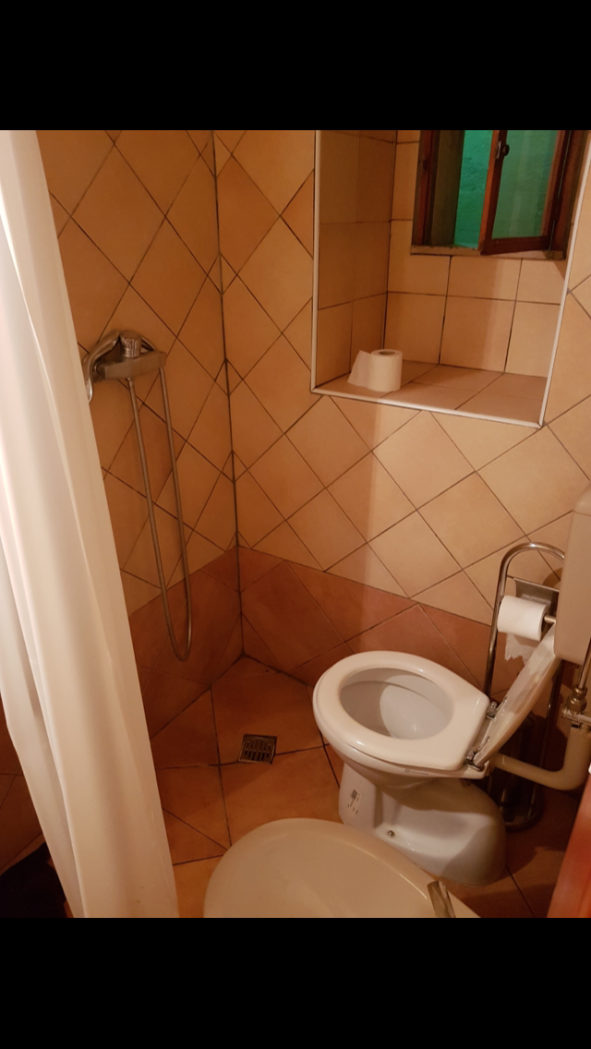

Zlé rozloženie kúpeľne - toaleta sa nachádza priamo v sprche. Sprchovať sa vedľa toalety môže byť nepríjemné a po použití sprchy je toaletná misa mokrá a papier premočený - nepoužiteľný.



Vyvýšený odtok v sprche - po použití sprchy voda neodteká, ale zostáva v sprche.

<https://www.art.yale.edu/>

* nečitateľný text
* neprehľadné rozloženie
* neintuitívna navigácia

Zmeny

* pozadie - pridali by sme jednofarebné pozadie, ktoré by zlepšilo čitateľnosť textu

<http://www.roverp6cars.com/?LMCL=ylvNGH>

* rušivé obrázky po bokoch
* pohyblivé, príliš veľké texty
* neprehľadné rozloženie

Zmeny

* pohyblivé texty by sme zmenili na nepohyblivé
* rušivé obrázky na pozadí by sme zmenili za jednofarebné pozadie

<https://www.fiit.stuba.sk>

* neintuitívna navigácia
* opakujúce sa názvy v rôznych záložkách menu
* komplikované vyhľadávanie informácií

Zmeny

* zlepšenie navigácie - napr. odstránenie duplicít

<https://is.stuba.sk/>

* neprehľadné a neintuitívne menu na hlavnej stránke
* zbytočná funkcionalita na úkor prehľadnosti, duplicita údajov

Zmeny

* zlepšenie navigácie - napr. odstránenie duplicít

## **Web App Topic (brainstorming)**

**Wishlist** - často sa stáva, že keď máme sviatok, nedostaneme darček, ktorý sme si priali. Niektoré darčeky dostaneme viackrát alebo ide o darčeky, ktoré nepotrebujeme. Prostredníctvom wishlist aplikácie by si človek mohol vytvárať zoznam darov, ktoré by chcel dostať a jeho rodina a priatelia by sa vedeli na jednotlivé dary prihlásiť a následne ich kúpiť.

**Donáška jedla priamo na internátnu izbu -** študenti z internátov často nemajú dostatok času na to, aby sa stihli ísť najesť do jedálne, prípadne aby si jedlo pripravili. Nepomáha tomu ani pandemická situácia, kvôli ktorej sa mnoho študentov do jedálni dostať nemôže alebo sa do nej ísť boja. Aplikácia by umožnila objednať si jedlo zo študentskej jedálne priamo na internátnu izbu.

**Čistenie okolia** - ľudia môžu čistiť okolie, v ktorom sa pohybujú od odpadkov a následne tieto vyčistené územia zaznačiť do mapy v aplikácii.

**Aplikácia pre seniorov** - nápad sme ďalej nerozvinuli.

## **User Research**

Adam

* Bývaš na internáte?

Áno, bývam na ŠD Mladosť.

* Aké formy stravovania používaš?

Momentálne si sám varím, pretože nie som očkovaný a nepustia ma do Eatu, kde to sa doteraz stravoval každý deň.

* Využívaš donáškové služby?

Nevyužívam, pretože reštaurácie, ktoré ich poskytujú sú pre mňa moc drahé.

* Ak by bola cenovo dostupná, tak by si využíval donáškovú službu priamo na internát?

Myslím, že áno. Momentálne by mi to veľmi pomohlo.

* Prečo? Aké sú výhody? Ako často?

Nemusel by som si stále variť, ušetrilo by mi to čas a námahu. Hlavne ako nezaočkovaný je to bez jedálne dosť náročné.

* Mal/a by si záujem privyrobiť si peniaze roznáškou jedla?

Keďže momentálne nemám brigádu, uvažoval by som nad takouto príležitosťou.

Dušan

* Bývaš na internáte?

Áno, bývam.

* Aké formy stravovania používaš?

Každý deň chodievam do Eatu.

* Využívaš aj donáškové služby?

Ani nie, keď som doma tak reštaurácie v mojom okolí neposkytujú takéto služby. Keď som v Bratislave na intráku, tak chodievam radšej do Eatu.

* A ak by bola dostupná donášková služba priamo z jedálne na tvoju internátnu izbu?

To by som využil.

* Prečo? Aké sú výhody? Ako často?

Výhodou by bolo, že by som nemusel vyjsť von z intráku. Najmä keď nie je dobré počasie alebo keď nestíham a potrebujem sa najesť popri zadaniach.

* Mal/a by si záujem privyrobiť si peniaze roznáškou jedla?

Ani nie, bol by som radšej, keby niekto doniesol jedlo mne.

Sofia

* Bývaš na internáte?

Áno.

* Aké formy stravovania používaš?

Niekedy si varím, niekedy chodím do blízkej jedálne.

* Využívaš donáškové služby?

Nevyužívam, pretože je dovoz drahý a produkuje sa pri tom zbytočný odpad.

* Ak by bola donáška cenovo dostupná a ekologická, tak by si využíval donáškovú službu zo školskej priamo na internát?

Raz za čas určite áno. V rozvrhu mám dni, kedy vôbec nemám čas ísť na obed.

* Prečo? Aké sú výhody? Ako často?

Ušetrilo by mi to dosť času, niekedy, keď by sa mi nechcelo ísť do jedálne, by som si tiež objednala jedlo na izbu. Minimálne 2x týždenne by som takúto službu určite využila.

* Mal/a by si záujem privyrobiť si peniaze roznáškou jedla?

Ak by bol pracovný čas flexibilný, tak možno áno.

Kevin

* Bývaš na internáte?

Áno.

* Aké formy stravovania používaš?

Stravujem sa prevažne v školskej jedálni.

* Využívaš donáškové služby?

Nevyužívam, pretože je dovoz drahý a neekologický.

* Ak by bola donáška cenovo dostupná a ekologická, tak by si využíval donáškovú službu zo školskej priamo na internát?

Určite áno.

* Prečo? Aké sú výhody? Ako často?

V dnešnej dobe sa bojím chodiť do jedálne, kde je veľa ľudí a vyššie riziko nakazenia sa koronavírusom. Tiež by mi to ušetrilo kopu času.

* Mal/a by si záujem privyrobiť si peniaze roznáškou jedla?

Záleží, koľko by som si tým zarobil, no nemám nič proti takejto práci.

## **User-oriented Specification**

## Na základe výsledkov z rozhovorov so študentmi a s prihliadnutím na aktuálnu situáciu týkajúcu sa koronavírusu sme sa rozhodli pre aplikáciu na rozvoz jedál zo školských jedální priamo na internáty. Študenti sú často zaneprázdnení a nemajú čas na teplý obed. Keďže mnohí nie sú zárobkovo činní, objednávky z okolitých reštaurácií sú pre nich cenovo nedostupné. Vzhľadom na aktuálnu pandemickú situáciu je roznáška jedál priamo na internát taktiež bezpečnejšia ako stretávanie veľkého množstva študentov v priestoroch jedálne. Časť študentov by zároveň uvítala možnosť zárobku rozvozom jedál, preto bude naša platforma poskytovať aj možnosť zamestnania sa ako kuriér.

## 

## **Personas**

### **Dušan**

**Age:** 22

**Location:** Bratislava

**Job:** Študent informatiky

**Bio:** Študent informatiky, ktorý momentálne býva na internáte ŠD Mladosť. Má rád dobré jedlo, avšak väčšinu času trávi vo svojej izbe. Je veľmi vyťažený štúdiom a čas, ktorý trávi cestou do jedálne a čakaním v rade by vedel zužitkovať lepšie.

**Needs & Goals:**

- Možnosť jedenia bez sociálnej interakcie a zbytočného pohybu.

- Lacné stravovanie.

**Tech:**

Internet 5/5

Social media 1/5

Online shopping 5/5

**Favourite portals:**

askalot.sk

eat&meet.sk

stackoverflow.com

**Frustrations:**

- Donáškové služby sú predražené.

- Preplnená jedáleň.

### **Alica**

**Age:** 21

**Location:** Bratislava

**Job:** Študentka filozofie

**Bio:** Študentka filozofie, ktorá momentálne býva na internáte Šturák. Vo voľnom čase sa venuje predaju esenciálnych olejov. Je vegánka. Napriek momentálnej pandemickej situácii nie je očkovaná. To jej značne sťažuje prístup do stravovacích zariadení.

**Needs & Goals:**

- Možnosť jedenia bez testu/očkovania.

- Zdravé, vegánske a cenovo dostupné stravovanie.

**Tech:**

Internet 3/5

Social media 5/5

Online shopping 4/5

**Favourite portals:**

zemavek.sk

zdraveoleje.sk

instagram.com

**Frustrations:**

- Potreba testu/očkovania do jedálne.

- Slabý výber vegánskych, cenovo dostupných jedál.

### **Braňo**

**Age:** 25

**Location:** Bratislava

**Job:** Študent FTVŠ

**Bio:** Študent FTVŠ. Keďže sa venuje športu, potrebuje kvalitnú, ale cenovo dostupnú stravu pre študenta. Takéto možnosti však nemá, pretože v jeho okolí sa nenachádza žiadna študentská jedáleň.

**Needs & Goals:**

- kvalitná, ale cenovo dostupná strava

- možnosť stravovania, za ktorým nemusí ďaleko dochádzať

**Tech:**

Internet 2/5

Social media 3/5

Online shopping 1/5

**Favourite portals:**

zlavomat.sk

nike.sk

**Frustrations:**

- v jeho okolí sa nenachádza žiadna študentská jedáleň

- reštaurácie a donáškové služby sú drahé

## 

## **User Scenarios**

#### Scenario 1 : Objednanie jedla neregistrovaným používateľom.

**Motivator:** V potravinách dnes nenašla čerstvú zeleninu, z ktorej by si navarila obed.

**Intention:** Potrebuje sa dostať k vegánskemu jedlu.

**Action:** Pri vyhľadávaní si zvolí filter s vegánskou stravou a vyberie si z dennej ponuky jedál v jednej z jedální a vyberie si čas doručenia.

**Resolution:** Alica si objedná jedlo bez registrácie.

*Backstory: Alica dnes v potravinách nenašla čerstvú zeleninu, z ktorej by si navarila obed.*

*Potrebuje sa dostať k vegánskemu jedlu, preto sa rozhoduje či navštívi vzdialenú predajňu alebo si prezrie ponuku jedál, ktoré sú dostupné v okolitých školských stravovacích zariadeniach. Ponuka je pre ňu zaujímavá, preto si vyberie a objedná jedno z jedál v konkrétnej jedálni. Keďže Alica nie je registrovaná, stránka jej túto možnosť ponúkne, avšak objednanie je možné aj bez nej. Tento krok preskočí a objedná si vegánske jedlo z lokálnej jedálne.*

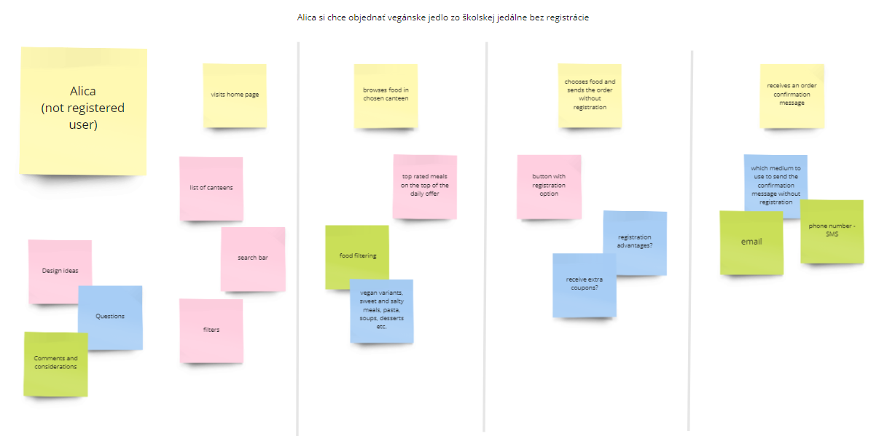

#### 

#### Scenario 2: Objednanie obľúbeného jedla registrovaným používateľom.

**Motivator**: Je hladný a nemá chuť za jedlom niekam chodiť.

**Intention**: Najesť sa na izbe v komfortnom prostredí.

**Action**: Dušan sa prihlási a overí si dostupnosť svojich obľúbených jedál vo svojom profile. Vyberie si jedlo z ponuky a keďže má na konte dostatočný kredit, platbu a zadávanie iných potrebných údajov môže rovno preskočiť a jedlo si objednať.

**Resolution**: Odošle objednávku a jedálenské zariadenie Dušanovi odošle správu o jej prijatí.

*Backstory: Dušan má dnes veľa prednášok a iba krátku pauzu na obed, preto sa chce najesť v pohodlí svojho internátu. Navštívi webovú stránku s ponukou jedál z okolitých jedální a prihlási sa do svojho konta. Jedlo si rýchlo vyberie zo svojich obľúbených a vďaka tomu, že má vytvorený účet, nemusí zadávať údaje potrebné pre doručenie a vykonanie platby. Objednanie jedla mu nezaberie ani 2 minúty a môže sa vrátiť naspäť k práci do školy.*

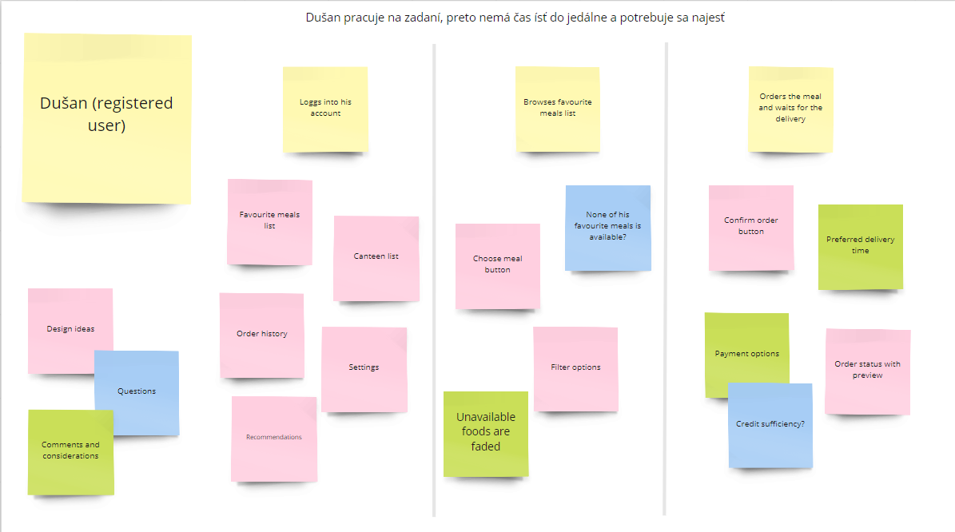

#### 

#### Scenario 3: Vytvorenie nového používateľského konta.

**Motivator:** Braňo si na futbalovom zápase zlomil nohu, čo mu značne sťažuje pohyb.

**Intention:** Potrebuje si pravidelne objednávať jedlo zo stravovacieho zariadenia.

**Action:** Braňo vyplní všetky údaje potrebné pre registráciu a vytvorí si osobné používateľské konto.

**Resolution:** Ako registrovaný používateľ môže rýchlo a jednoducho vytvárať objednávky.

*Backstory: Braňo si na futbalovom zápase zlomil nohu, čo mu značne sťažuje pohyb. V nasledujúcich týždňoch bude potrebovať veľa donášok jedla, keďže je študent a športovec, potrebuje sa najesť zdravo a lacno s možnosťou donášky jedla priamo na izbu. Vyhľadávač ho presmeruje na jedálenskú stránku. Tá sa mu zapáči a rozhodne sa registrovať, aby stále nemusel zadávať rovnaké údaje pre donášku a platbu. Braňo vyplní všetky údaje potrebné pre registráciu a vytvorí si osobné používateľské konto.*

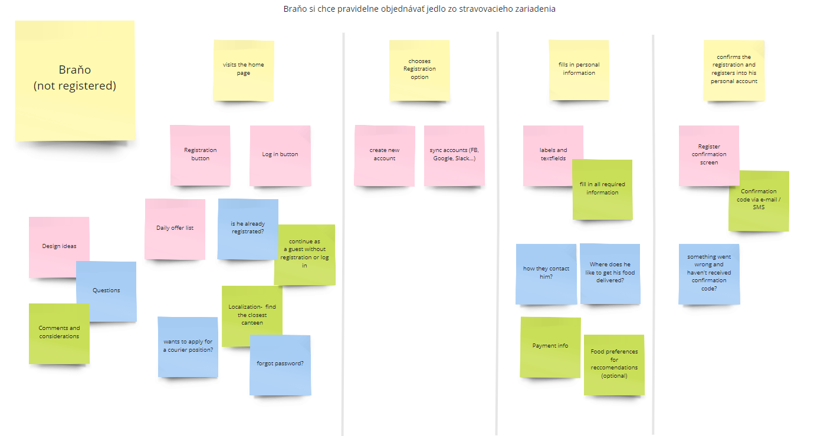

#### 

#### Scenario 4: Spracovanie objednávky registrovaným kuriérom.

**Motivator:** Braňo má objednávku, ktorú musí vybaviť.

**Intention:** Braňo očakáva objednávky aby mohol zarobiť.

**Action:** Webová aplikácia Braňovi pošle notifikáciu s podrobnosťami o objednávke. Braňo z nej prečíta potrebné informácie a objednávku ide doručiť.

**Resolution:** Objednávka bola vybavená, Braňo zarobil peniaze a iný zákazník dostal jedlo.

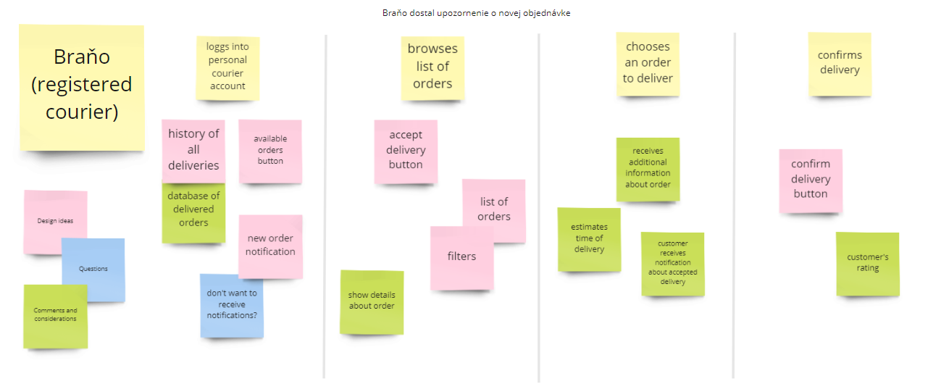

#### 

#### Scenario 5: Registrácia nového kuriéra.

**Motivator:** Alica nemá peniaze a preto si potrebuje privyrobiť.

**Intention:** Potrebuje si nájsť jednoduchú brigádu v okolí internátu.

**Action:** Alica vyplní všetky údaje potrebné pre registráciu kuriéra a vytvorí si používateľské konto.

**Resolution:** Alica môže prijímať, vyzdvihovať a doručovať objednávky.

*Backstory:* *Alica momentálne nemá dostatok peňazí, preto sa rozhodla, že si privyrobí. Potrebuje si nájsť brigádu, ktorá je jednoduchá a v blízkosti jej internátu. Rozhodla sa, že bude roznášať jedlo objednané z lokálnej študentskej jedálne. Vyplní potrebné informácie a zaregistruje sa ako kuriér.*

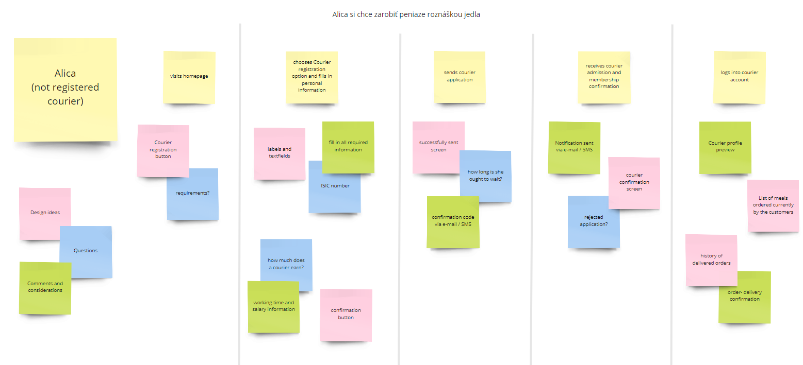

## 

## **Information Architecture**

Platforma Bistro.sk poskytuje podobné služby ako naša zamýšľaná webová aplikácia - okrem možnosti objednania rôznych jedál na donášku poskytuje používateľovi aj možnosť zamestnať sa ako rozvozca jedál.

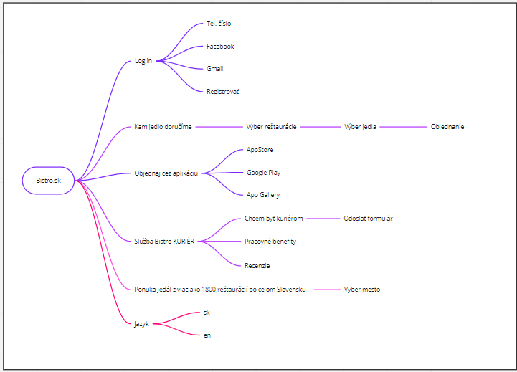

#### Návrh informačnej architektúry aplikácie Eat not Meet:

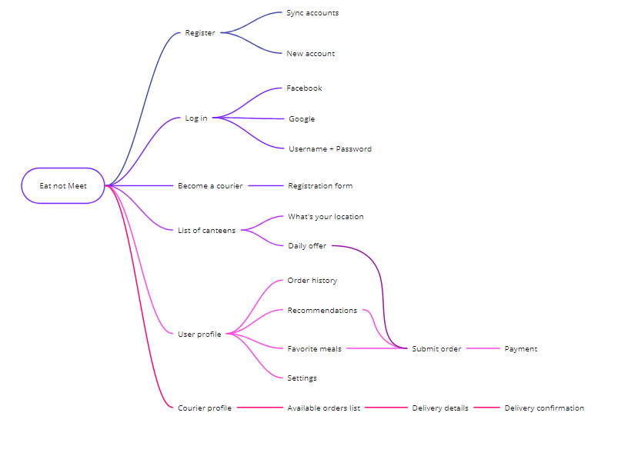

#### Card sorting:

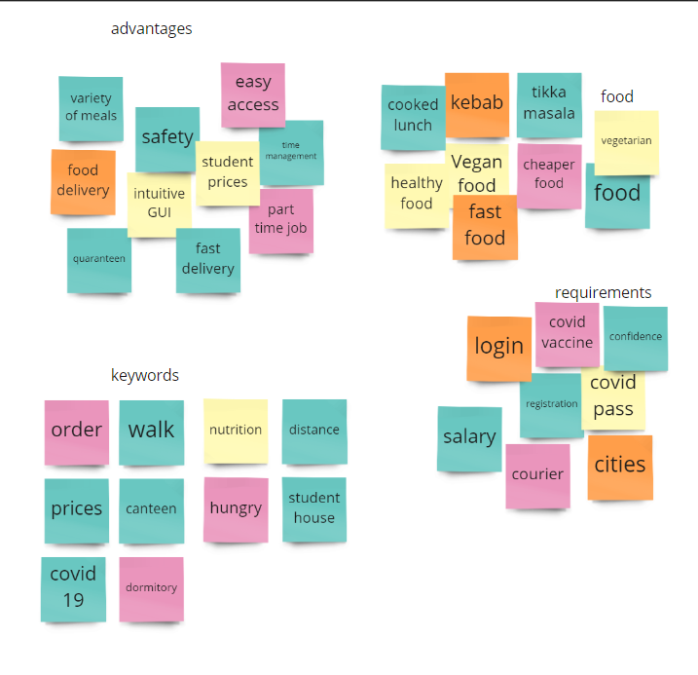

#### 

#### Scenario 1: Objednanie jedla neregistrovaným používateľom.

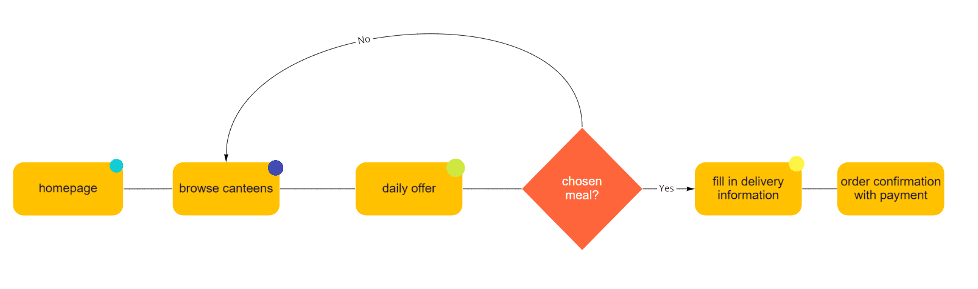

#### 

#### Scenario 2: Objednanie obľúbeného jedla registrovaným používateľom.

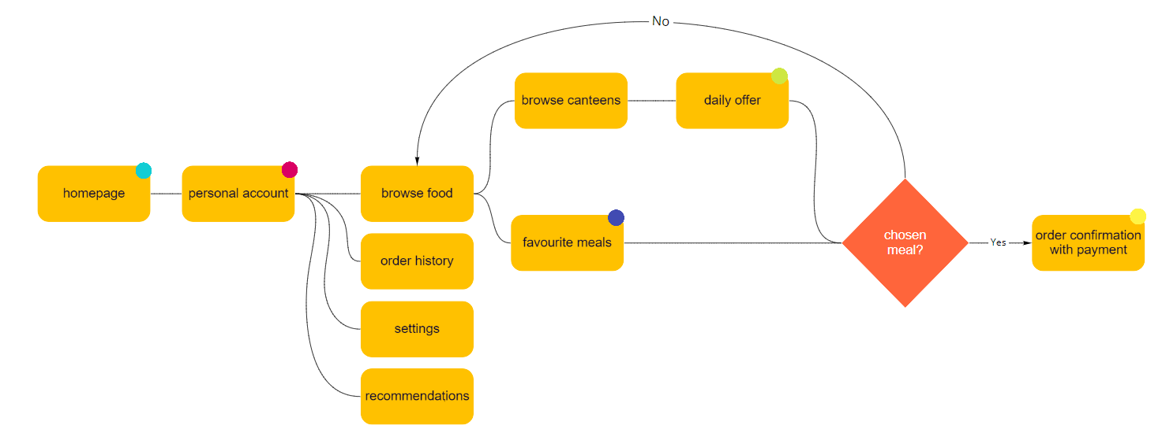

#### 

#### 

#### Scenario 3: Vytvorenie nového používateľského konta.

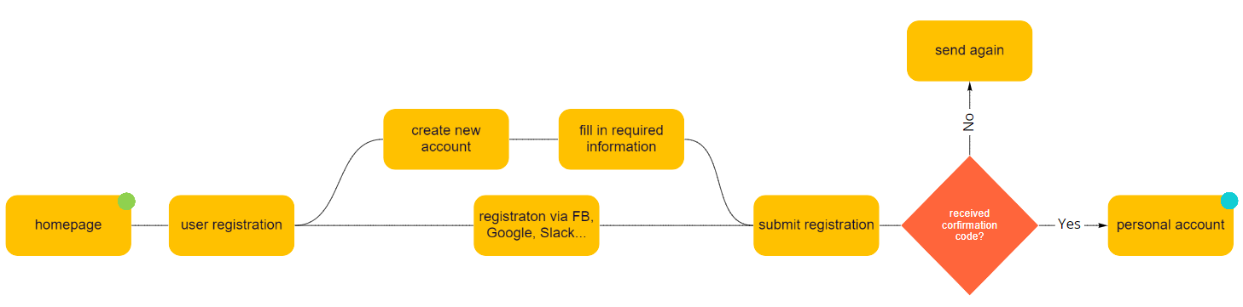

#### 

#### Scenario 4: Spracovanie objednávky registrovaným kuriérom.

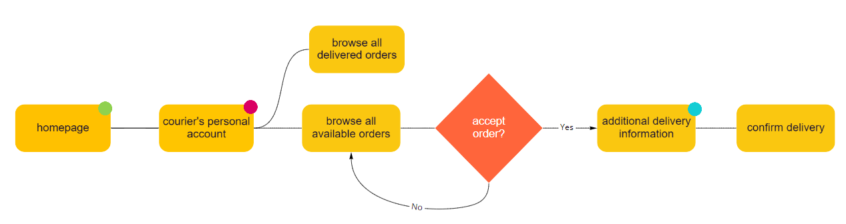

#### 

#### Scenario 5: Registrácia nového kuriéra.

# 

# 

# **Prototyping Phase**

# **2.1 Low-Fidelity Prototype (1st iteration)**

### Scenario 1: Objednanie jedla neregistrovaným používateľom.

### 

### Scenario 2 : Objednanie obľúbeného jedla registrovaným používateľom.

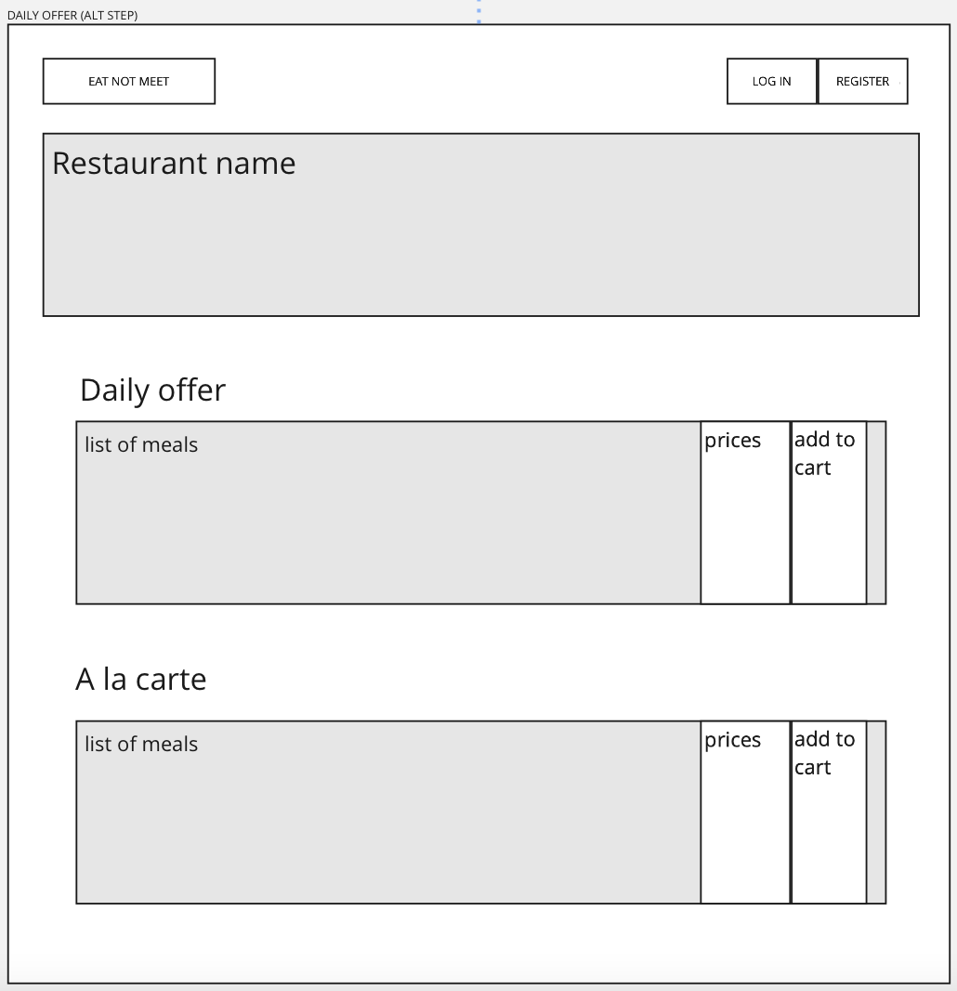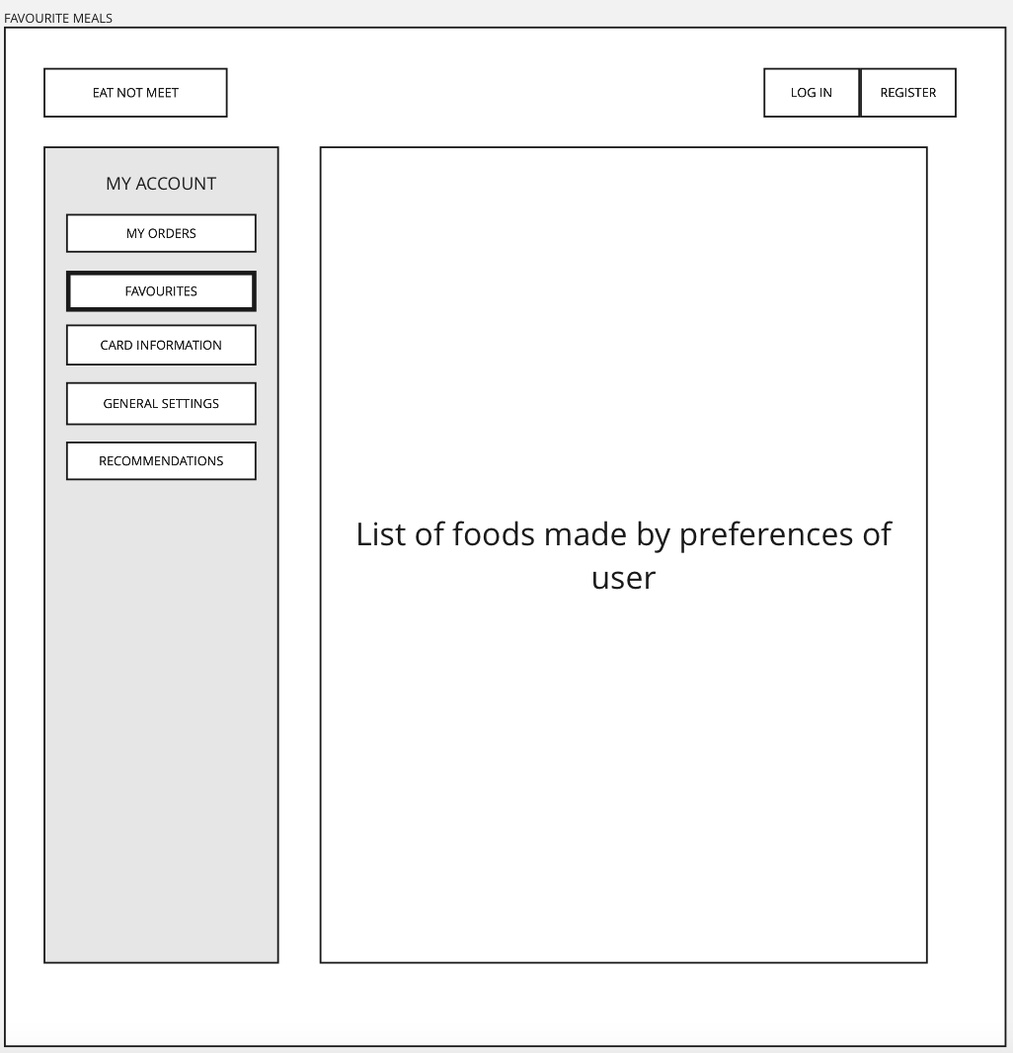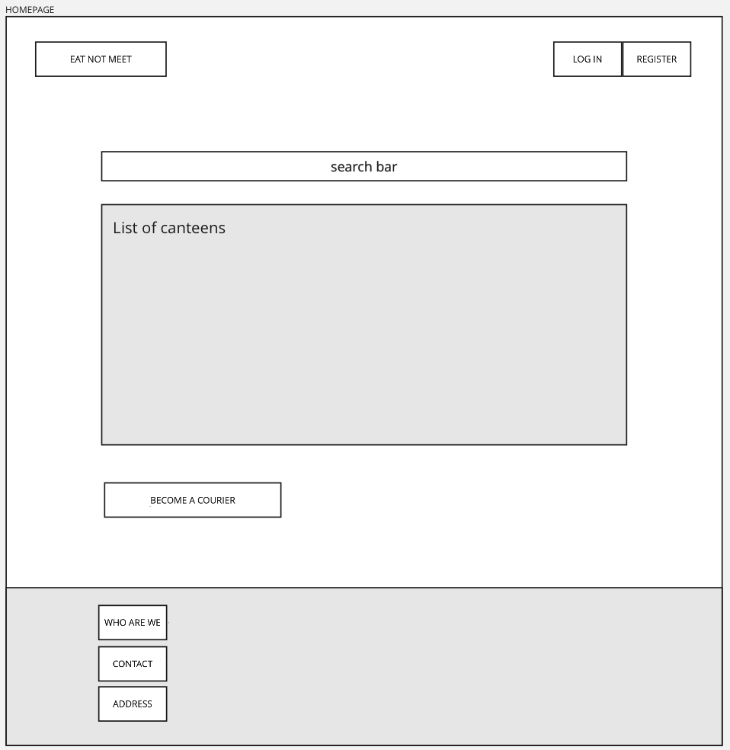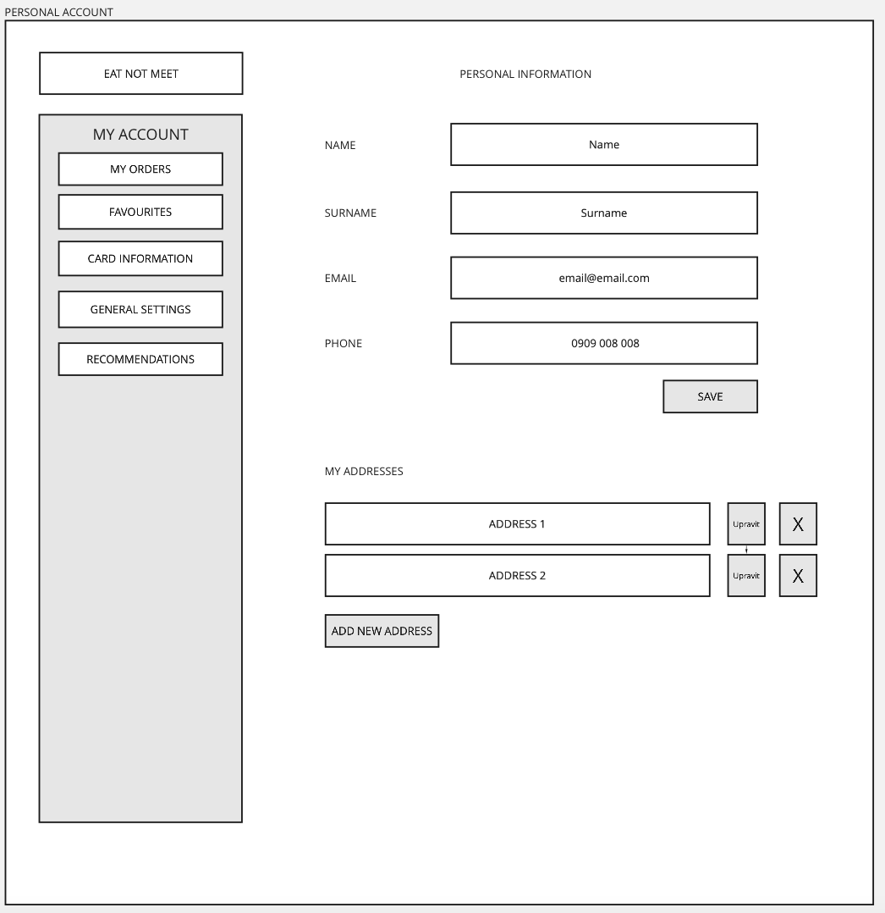

## 

## 

## 

## 

## 

## 

### Scenario 3: Vytvorenie nového používateľského konta.

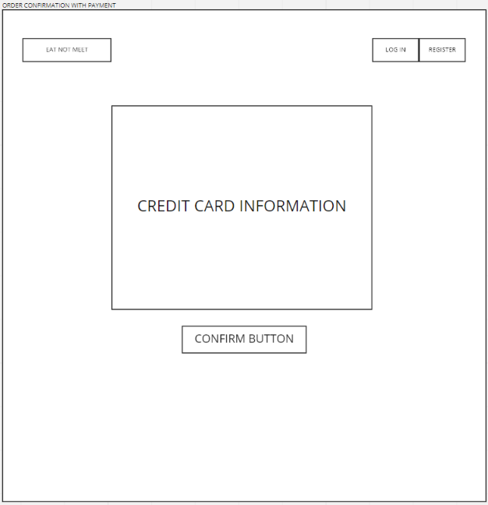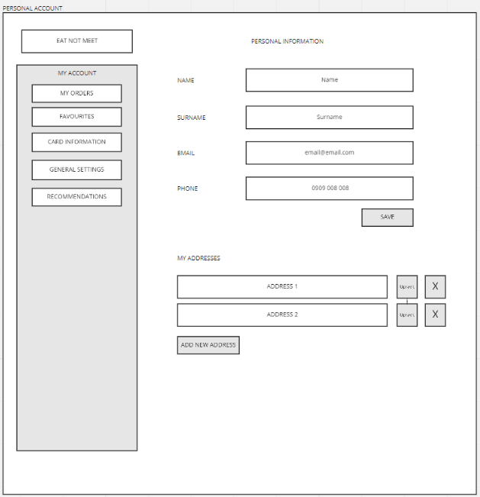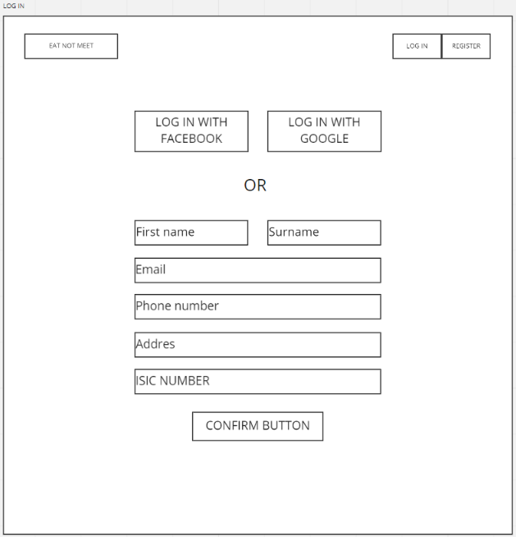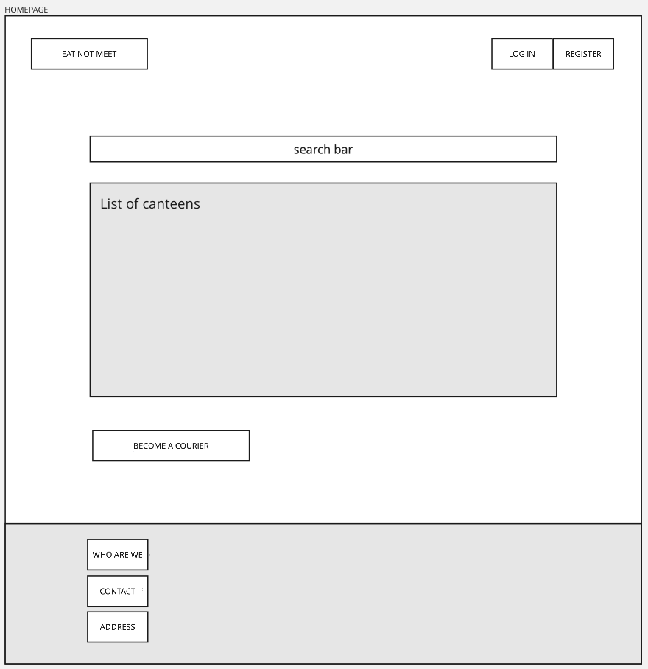

### Scenario 5: Registrácia nového kuriéra.

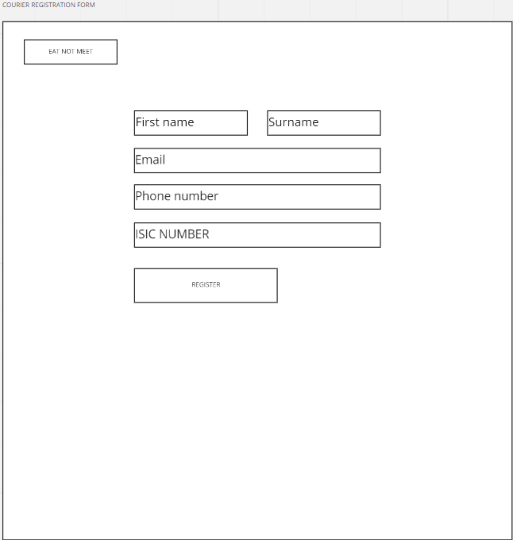

### Scenario 4: Spracovanie objednávky registrovaným kuriérom.

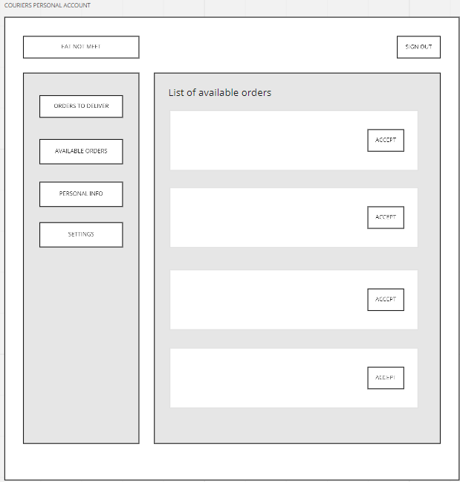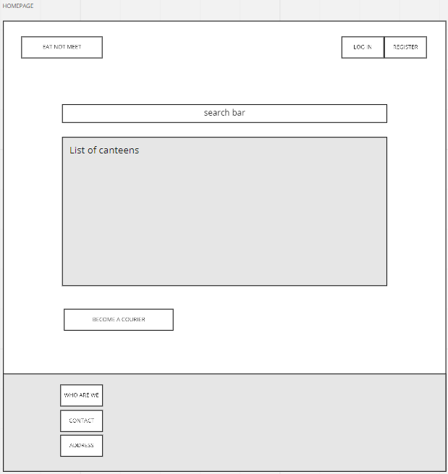

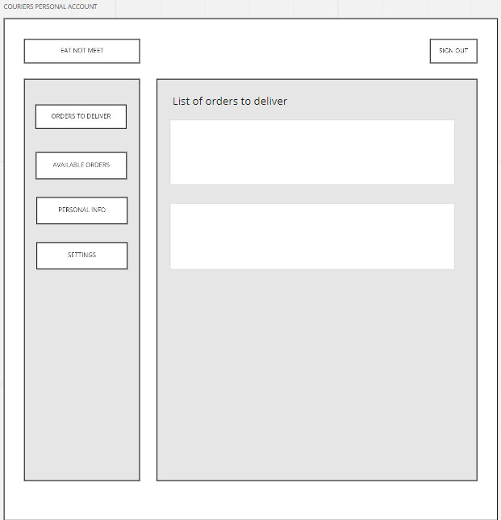

## 

## **Low-Fidelity Prototype (2nd iteration)**

### Scenario 1: Objednanie jedla neregistrovaným používateľom.

### 

### 

### 

### 

### 

### 

### 

### 

### 

### 

### 

### 

### Scenario 2 : Objednanie obľúbeného jedla registrovaným používateľom

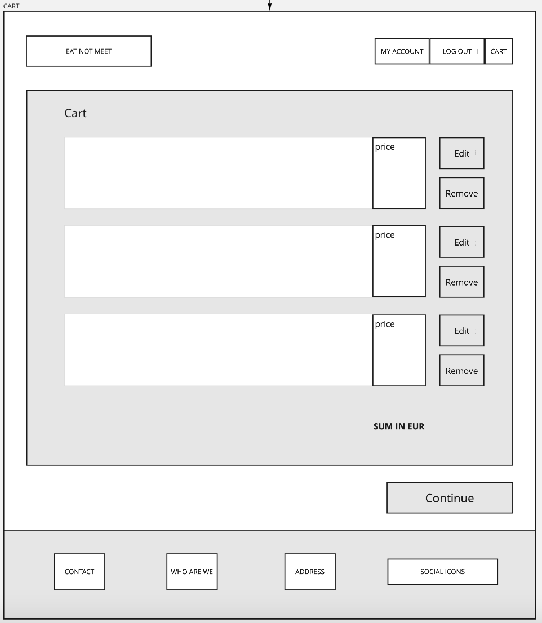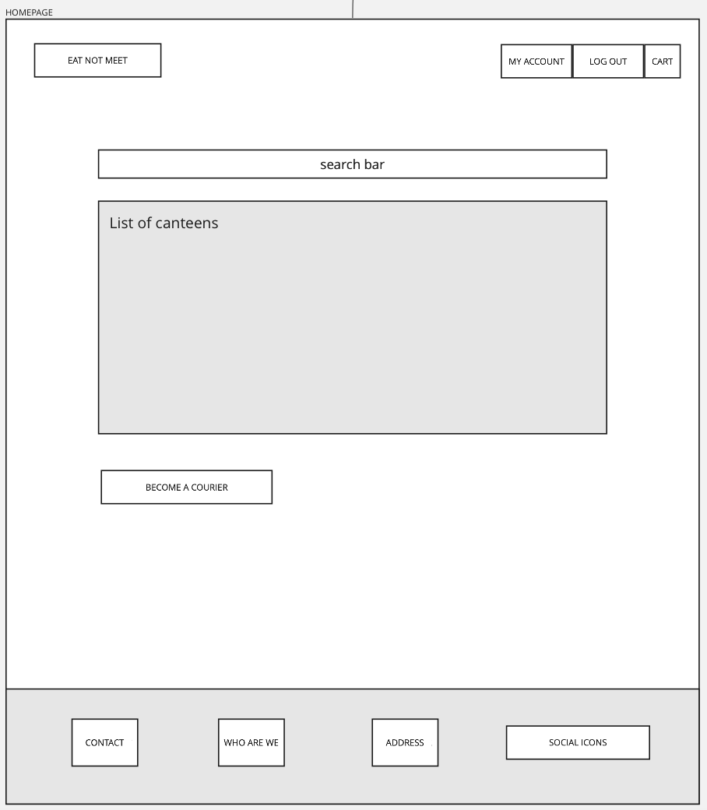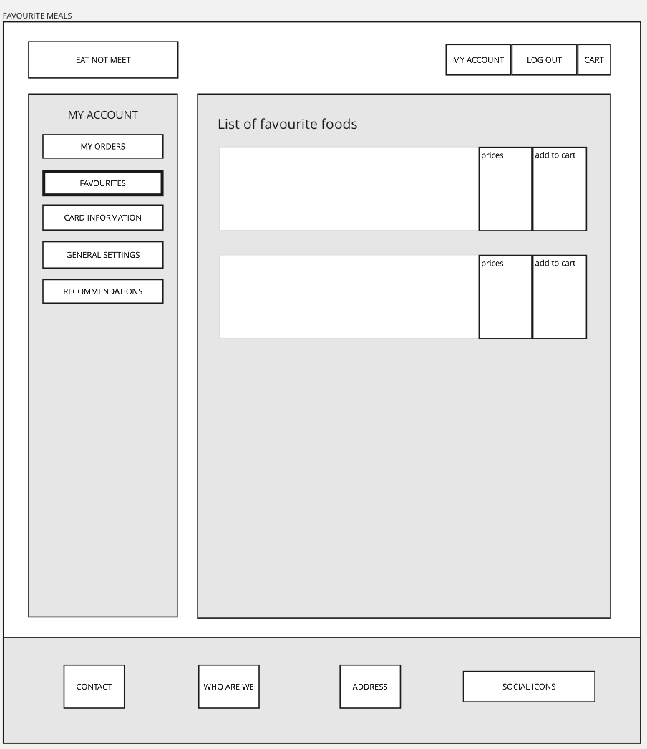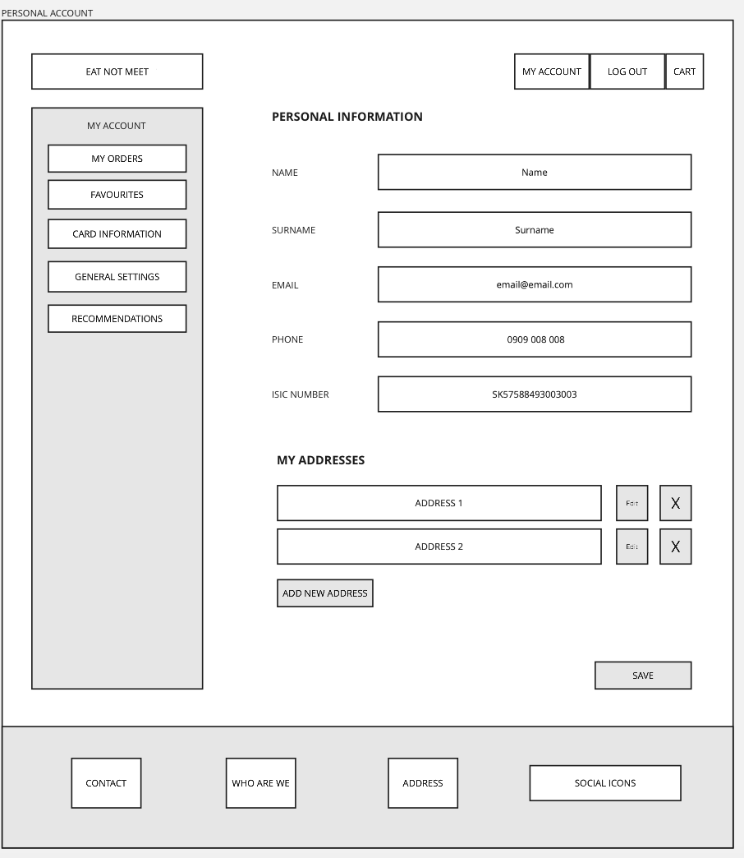

### 

### 

### Scenario 3: Vytvorenie nového používateľského konta.

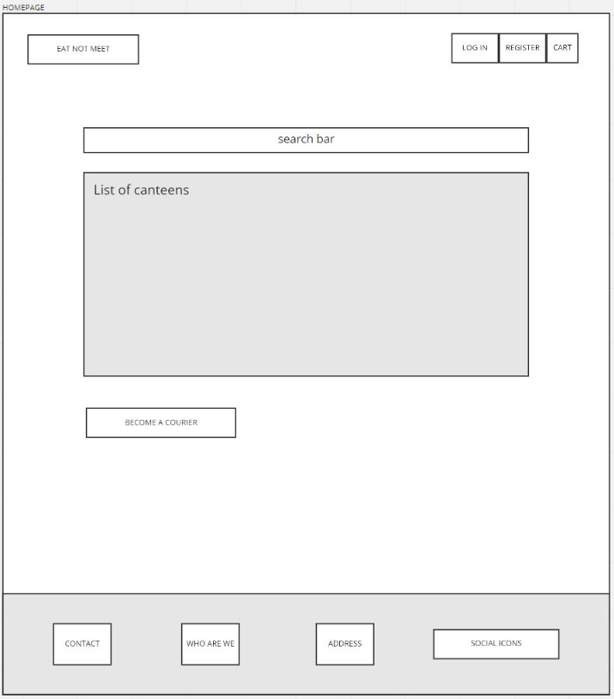

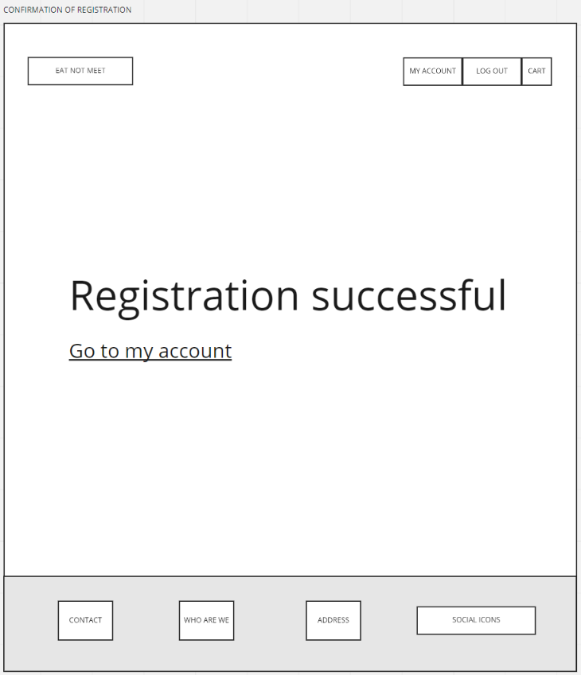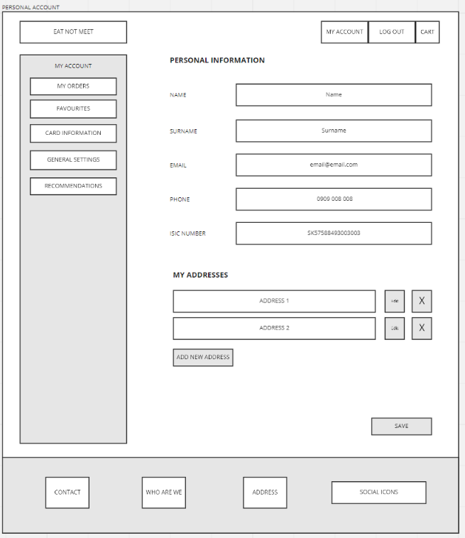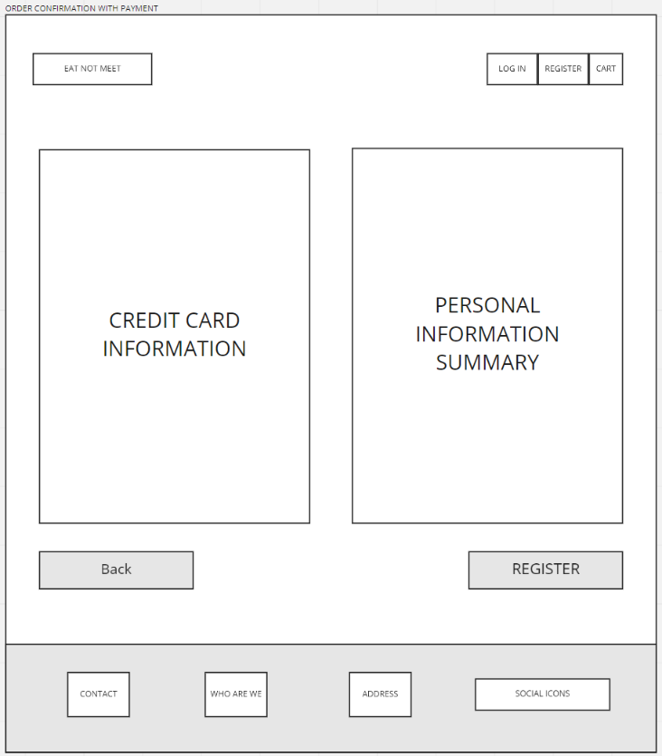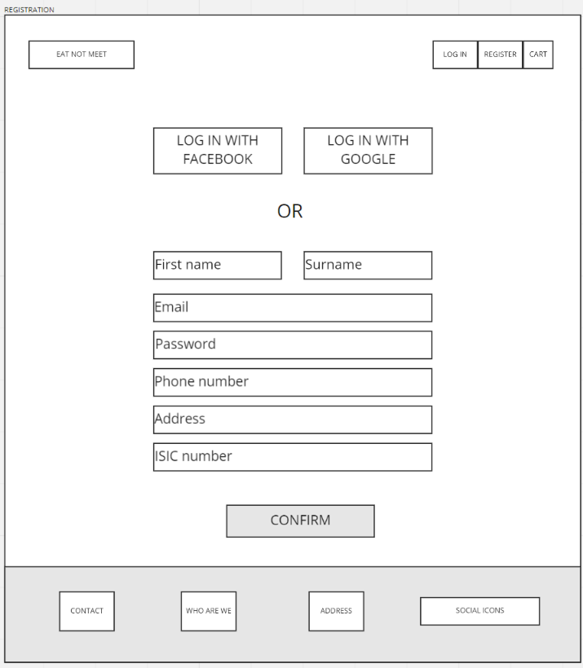

### Scenario 5: Registrácia nového kuriéra

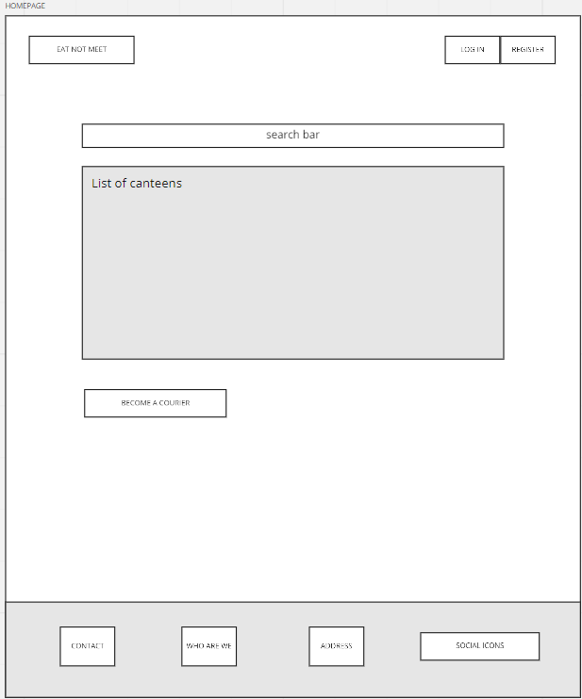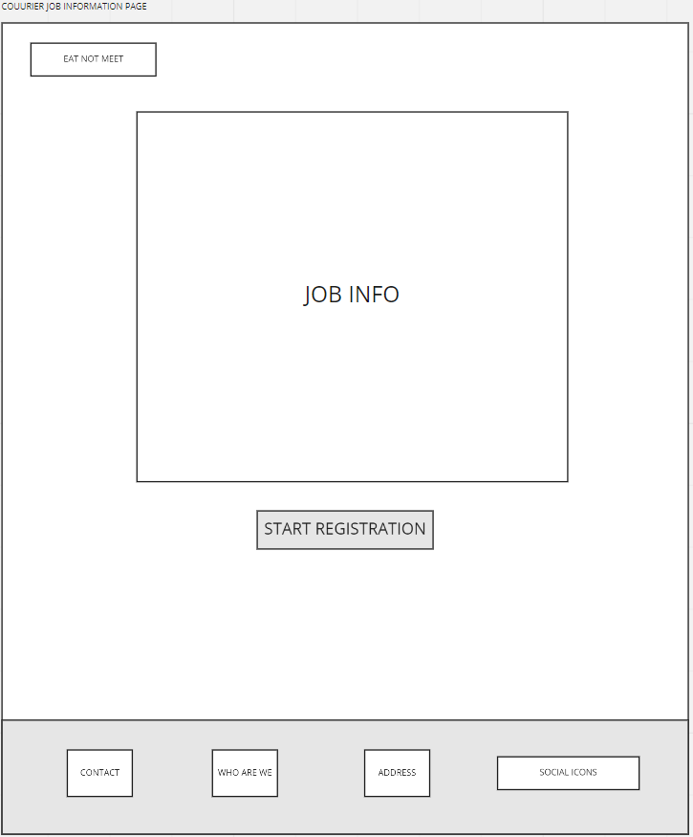

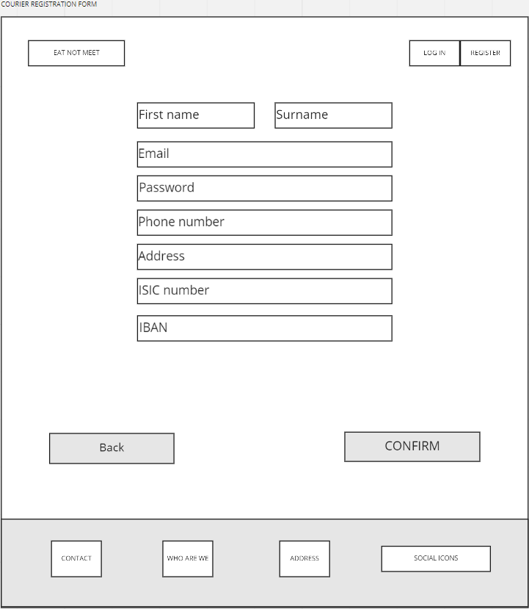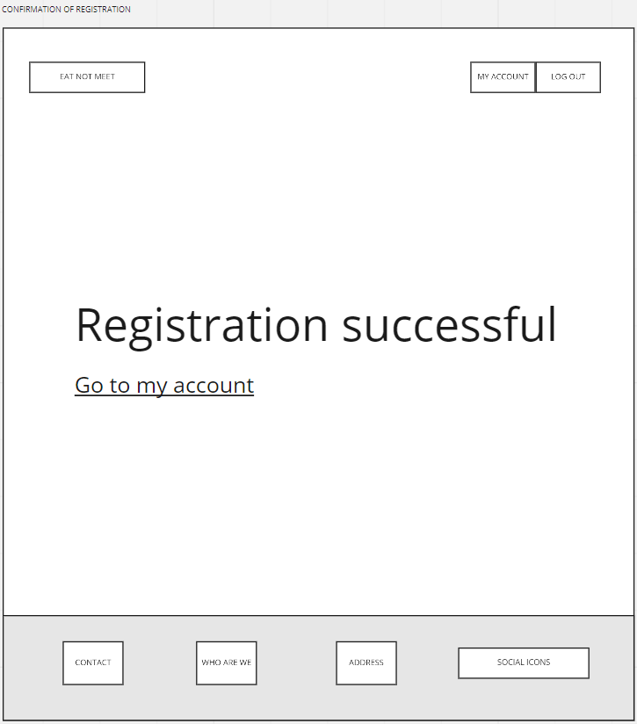

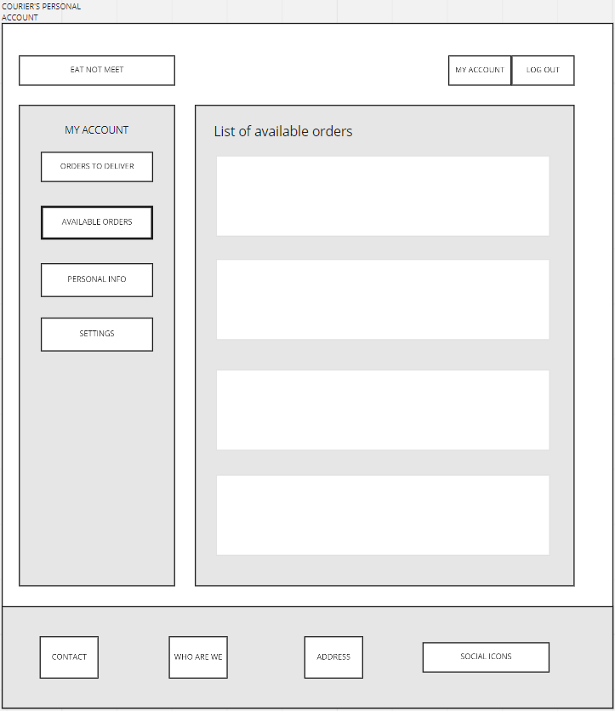

### Scenario 4: Spracovanie objednávky registrovaným kuriérom.

### 

## V rámci testovacej fázy sme našli mnoho chýb, ktoré sme následne opravili. Vďaka tomu, že sme mnohé nedostatky odhalili v low fidelity fáze, vyhli sme sa problémom, ktoré by nás v budúcnosti stáli omnoho viac síl.

## Pridanie košíka do menu

## Úprava pätičky na všetkých stránkach

## Pridanie back a confirm buttonov, ktoré na mnohých stránkach chýbali

## Pridanie zhrnutia objednávky

## Pridanie chýbajúcich input fields (ISIC number, iban)

## Pridanie obrazovky prehľad mojich objednávok

## Pridanie obrazovky s popisom práce kuriéra

## Doplnenie chýbajúcich obrazoviek do správneho workflow registrácie kuriéra

## Pridanie edit buttonov a buttonu pre potvrdenie doručenia objednávky kuriérom

## Úprava menu pre prihlásených užívateľov

## **High-Fidelity Prototype (1st iteration)**

### Scenario 1: Objednanie jedla neregistrovaným používateľom.

### 

### 

### 

### 

### 

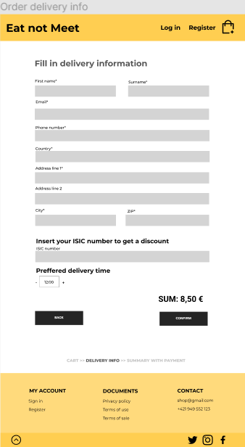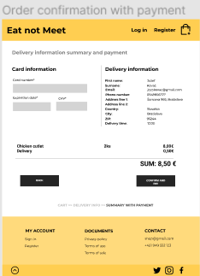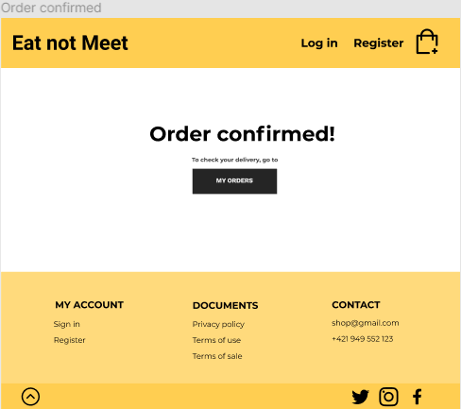

### Scenario 2 : Objednanie obľúbeného jedla registrovaným používateľom.

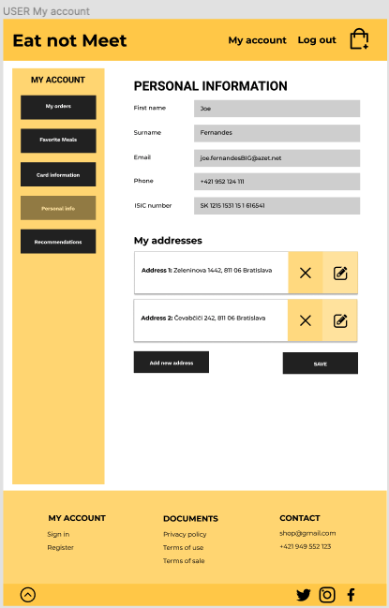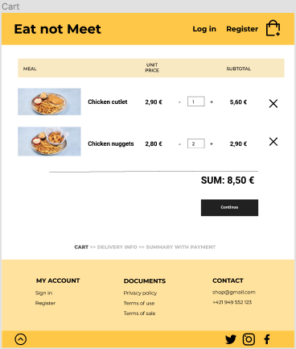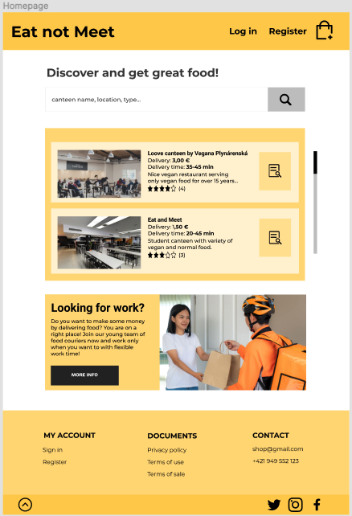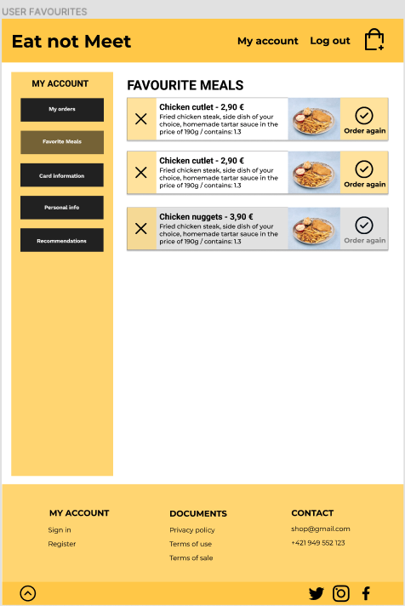

### 

### Scenario 3: Vytvorenie nového používateľského konta.

### 

### Scenario 4: Spracovanie objednávky registrovaným kuriérom.

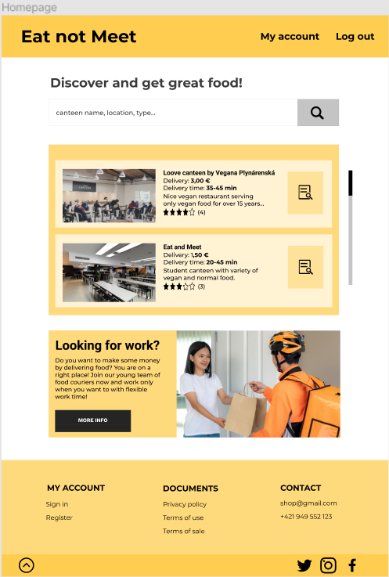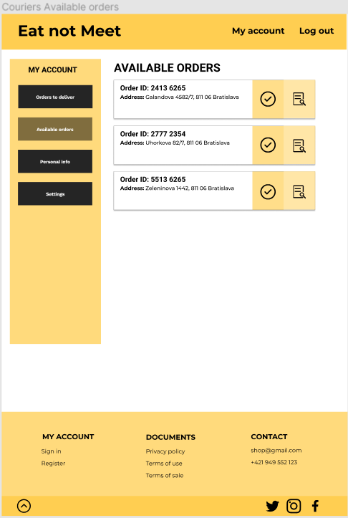

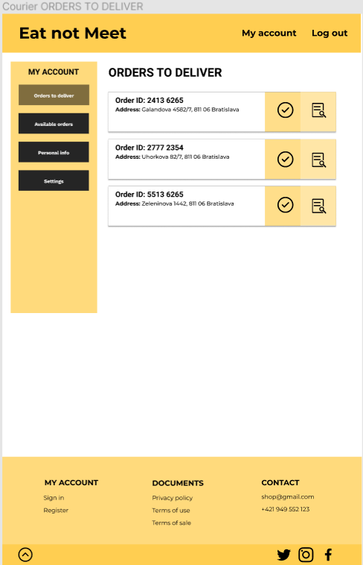

### Scenario 5: Registrácia nového kuriéra

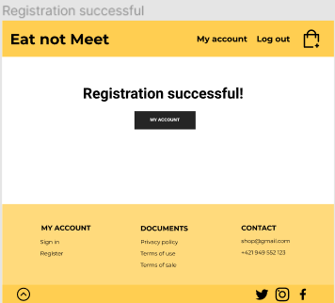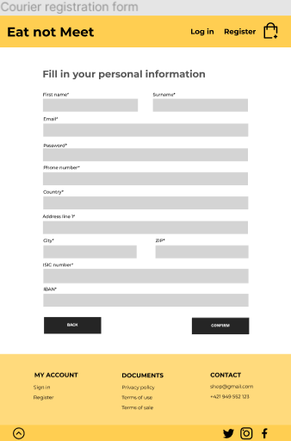

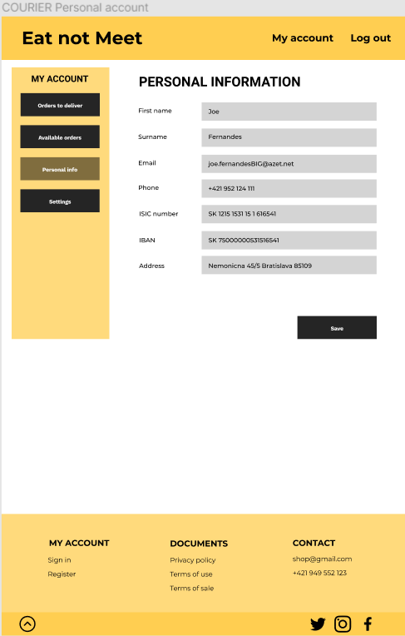

## 

## **Expert Testing**

# Heuristic Evaluation

**Team nr.:**  4

**Prototype by team nr.:** 1

**Heuristics used:**  [Usability Heuristics by Jakob Nielsen](https://www.nngroup.com/articles/ten-usability-heuristics/)

1. Visibility of system status
2. Match between system and the real world
3. User control and freedom
4. Consistency and standards
5. Error prevention
6. Recognition rather than recall
7. Flexibility and efficiency of use
8. Aesthetics and minimalistic design
9. Help users with errors
10. Help and documentation

**Severity rating:**

0) I don’t agree this is a usability problem at all

1) Cosmetic problem only: need not be fixed unless extra time is available on project

2) Minor usability problem: fixing this should be given low priority

3) Major usability problem: important to fix, so should be given high priority

4) Usability catastrophe: imperative to fix this before product can be released

### Implementované zmeny oproti prvej iterácii:

1. pridanie labelu order history v user account

2. premenovanie buttonov v menu kuriéra   
 AVAILABLE ORDERS -> AVAILABLE ORDERS TO DELIVER

ORDERS TO DELIVER -> MY ACTIVE ORDERS

3. pridanie BACK buttonu na detail stránky jedálne (daily offer)

4. pridanie labelu UNAVAILABLE pri nedostupnom obľúbenom jedle

7. pridanie labelu Canteens na homepage

10. preddefinovaný text vo vpisovacích poliach

Iné zmeny:

zjednotenie formátu textu na buttonoch

|  | **Severity** | **Strengths** | **Problems** | **Recommendations** |
| --- | --- | --- | --- | --- |
| **1** | 2 | Pri objednávke vidieť status | V “My orders” nie je jasne označené, čo sú objednávky z minulosti | Pridať nadpis “História objednávok” |
| **2** | 3 | Zrozumiteľné typy ikon | Available orders - čo to znamená? | Premenovať “available orders” na niečo exaktnejšie |
| **3** | 2 | Možnosť návratu pri objednávaní | Chýba back button pri listingoch | Pridat back button. Ponúknuť užívateľovi riešiť problém s nedoručenou objednávkou. |
| **4** | 1 |  | Napr. v účte kuriéra sú rôzne veľkosti stránok Orders to deliver a Available orders. Pri klikaní na My Account ma to presmeruváva medzi dvoma stránkami(personal info a my orders). Favourite meals vyšedené jedlo ->? nemožnosť objednať? | Show nedostupné oblubene jedlá. Pri kliknutí na účet zobrazovať vždy len My orders. |
| **5** | 0 | Možnosť návratu |  |  |
| **6** | 0 | Pri obrázku jedalne si skôr spomeniem. Tak isto aj pri ikonách. |  |  |
| **7** | 2 | Viem sa prihlásiť ako kuriér aj ako zákazník | Chýba osobitná stránka na ktorej sú jedálne | Pridať osobitnú stránku s jedálňami |
| **8** | 0 | Pekné farby, nie prehnane vela elementov na každej stránke |  |  |
| **9** | 0 |  |  |  |
| **10** | 0 |  |  | Pridať vysvetlivky pri zadávaní osobných údajov. |

## 

## **High-Fidelity Prototype (2nd iteration)**

### Scenario 1: Objednanie jedla neregistrovaným používateľom.

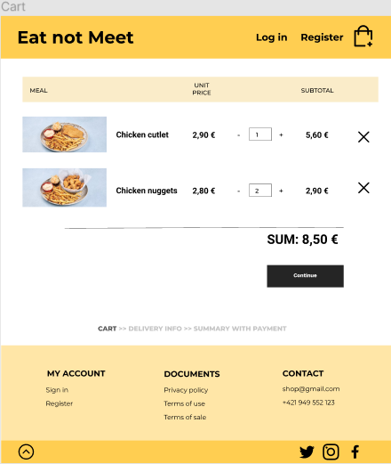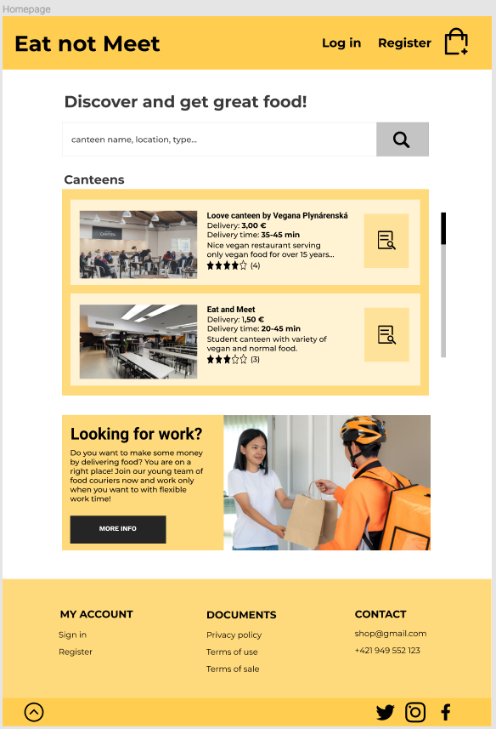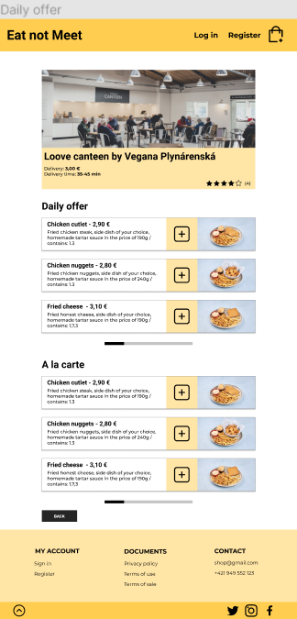



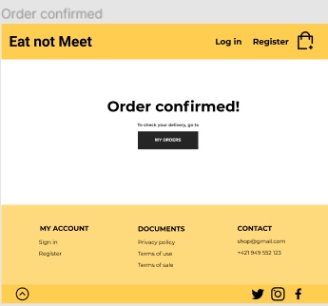

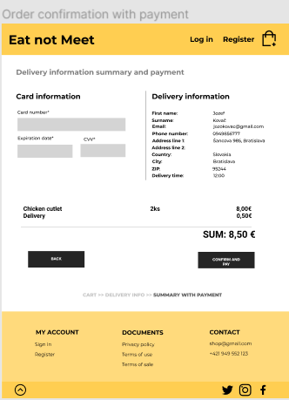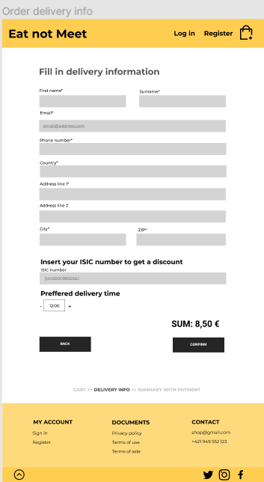

### Scenario 2 : Objednanie obľúbeného jedla registrovaným používateľom.

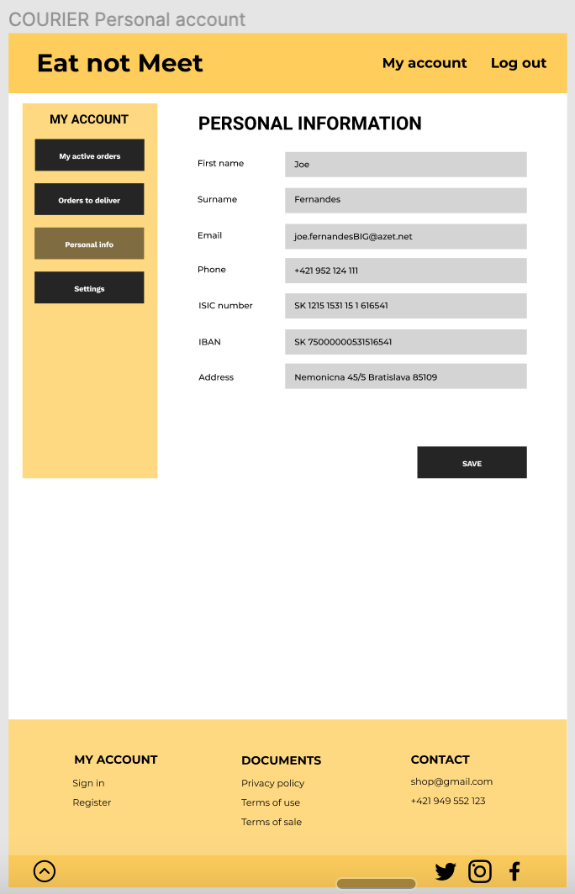

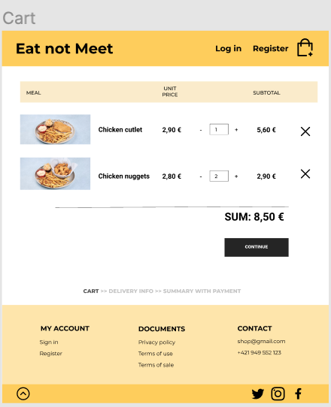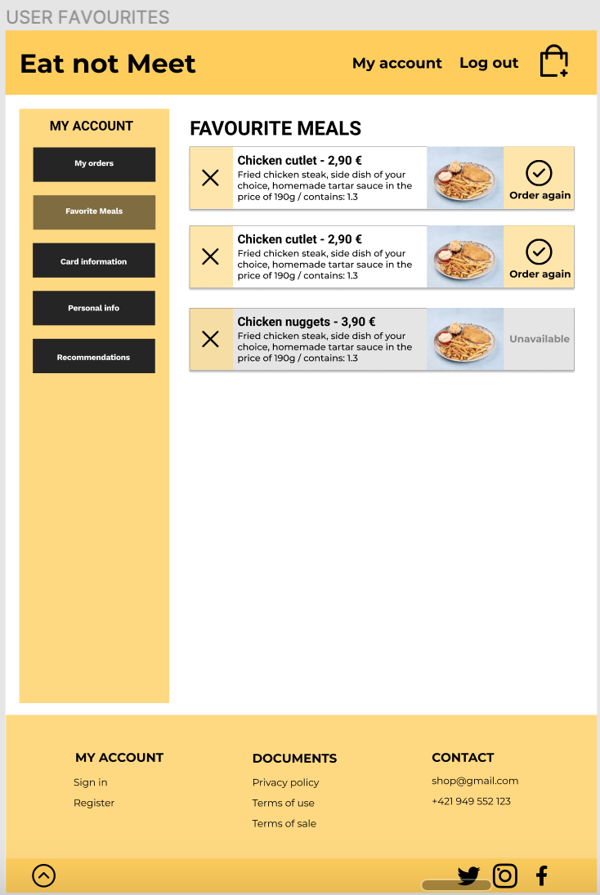

### 

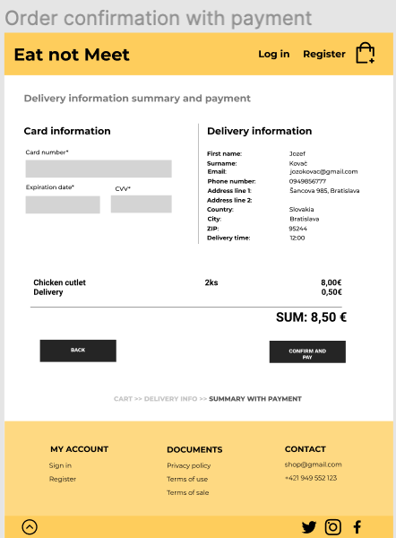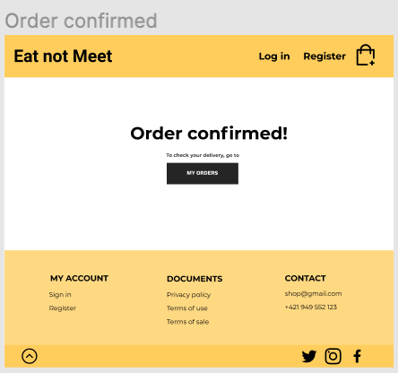

### Scenario 3: Vytvorenie nového používateľského konta.

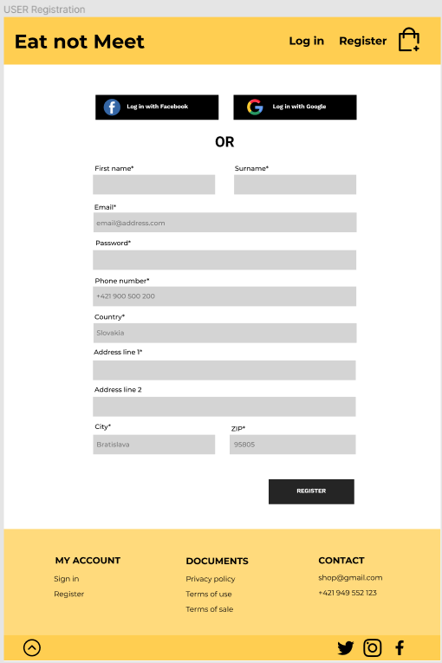

### 

### Scenario 4: Spracovanie objednávky registrovaným kuriérom.

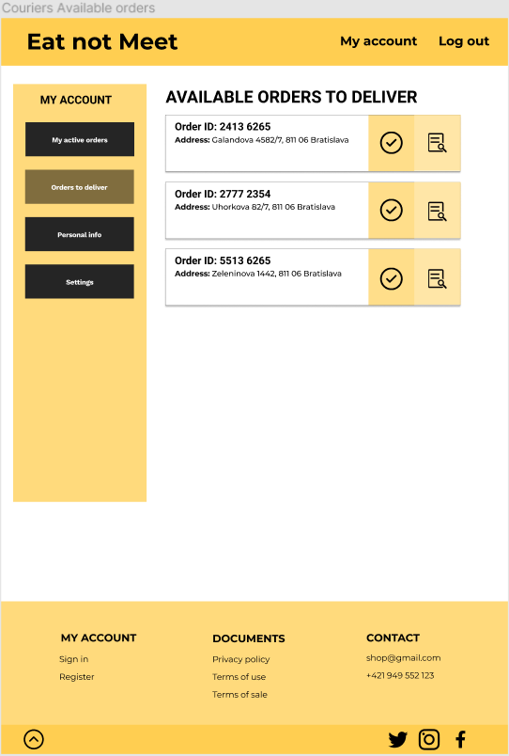

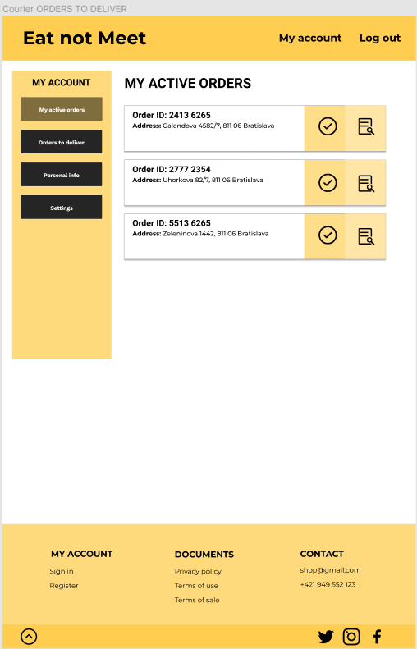

### Scenario 5: Registrácia nového kuriéra

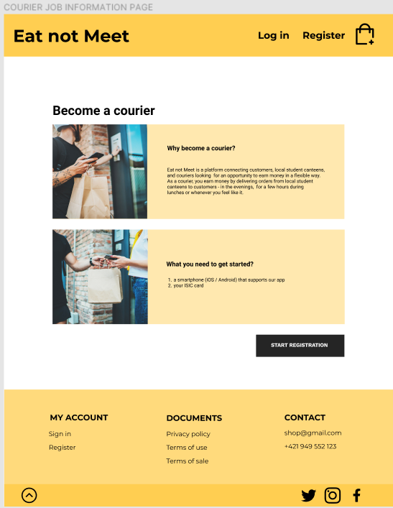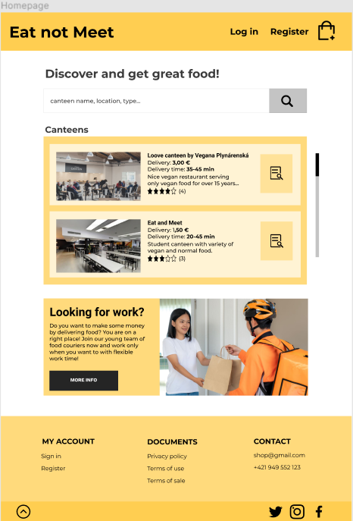

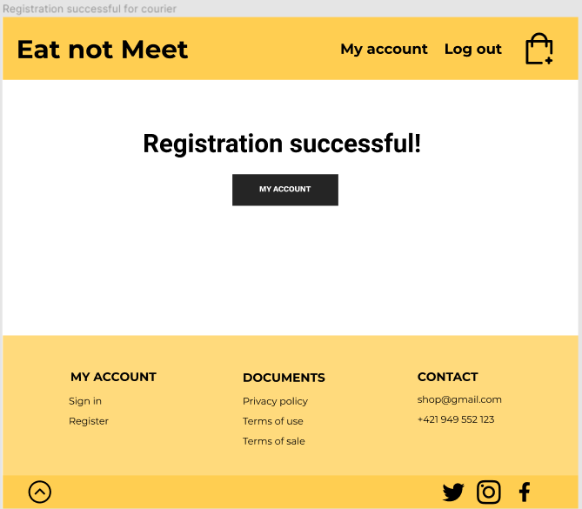

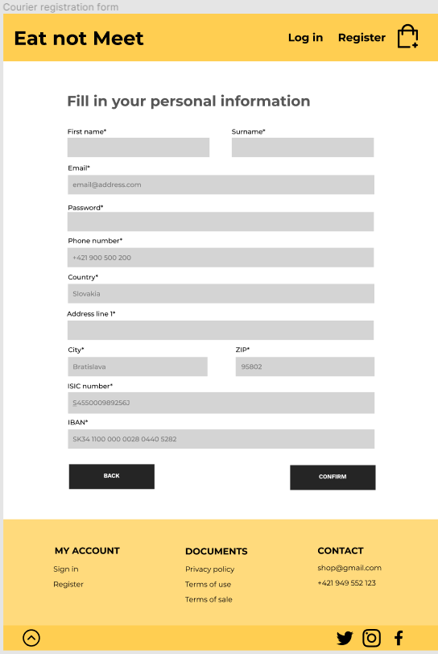

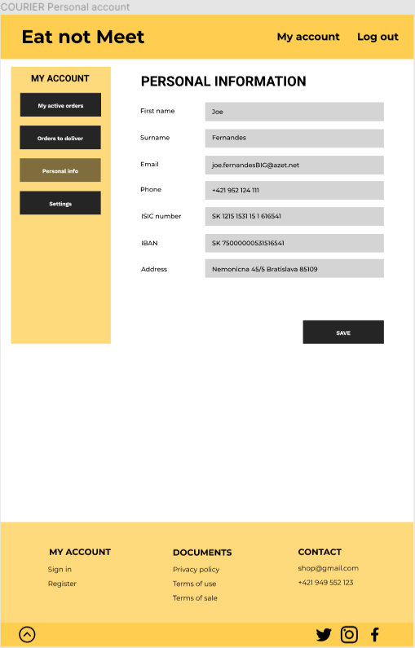

# **3 Usability Testing Phase**

# **Usability Test Report**

### **Name of tested web/application**

Eat not meet

### **Place, date**

Bratislava  
15. - 21 . 11. 2021

## **Summary**

1. *Find a list of my orders to deliver in a courier account.*Users struggled to find the list of orders to deliver after logging into their courier account. They were confused about the labels *My personal orders* and *All orders to deliver*.  
   We would solve this problem by changing the label to something more explanatory. We would also add a short description of the purpose to both of these 2 screens.
2. *Register as courier*Users couldn’t find the right form for registration as a courier, they started filling out the wrong registration form as a user.   
   Our solution is to add courier registration option to the footer and also to the header - as an additional option next to the user registration for easier access.
3. *Payment options*Users would like to have more than one current option to pay for their orders. They felt like card payment isn’t always the safest option.  
   We would solve this problem by adding another step to the checkout process - users would be able to choose from a list of payment options.
4. *Additional information about courier position*  
   Participants would appreciate more information about current courier position, e.g. wage info, legal documents...  
   We would add more information to the courier registration process. Information such as job requirements, wage, work environment and legal process.
5. *Additional information about canteens*Testers were missing some information about canteens, e.g. opening hours, location and map.  
   We would add more important information, including opening hours and location. We would also provide an interactive map with canteens.
6. **Test Procedure Description**

### **User Profiles**

### **DUŠAN**

**Age:** 22

**Location:** Bratislava

**Job:** Študent informatiky

**Bio:** Študent informatiky, ktorý momentálne býva na internáte ŠD Mladosť. Má rád dobré jedlo, avšak väčšinu času trávi vo svojej izbe. Je veľmi vyťažený štúdiom a čas, ktorý trávi cestou do jedálne a čakaním v rade by vedel zužitkovať lepšie.

**Needs & Goals:**

- Možnosť jedenia bez sociálnej interakcie a zbytočného pohybu.

- Lacné stravovanie.

**Tech:**

Internet 5/5

Social media 1/5

Online shopping 5/5

**Favourite portals:**

askalot.sk

eat&meet.sk

stackoverflow.com

**Frustrations:**

- Donáškové služby sú predražené.

- Preplnená jedáleň.

### **ALICA**

**Age:** 21

**Location:** Bratislava

**Job:** Študentka filozofie

**Bio:** Študentka filozofie, ktorá momentálne býva na internáte Šturák. Vo voľnom čase sa venuje predaju esenciálnych olejov. Je vegánka. Napriek momentálnej pandemickej situácii nie je očkovaná. To jej značne sťažuje prístup do stravovacích zariadení.

**Needs & Goals:**

- Možnosť jedenia bez testu/očkovania.

- Zdravé, vegánske a cenovo dostupné stravovanie.

**Tech:**

Internet 3/5

Social media 5/5

Online shopping 4/5

**Favourite portals:**

zemavek.sk

zdraveoleje.sk

instagram.com

**Frustrations:**

- Potreba testu/očkovania do jedálne.

- Slabý výber vegánskych, cenovo dostupných jedál.

### **BRAŇO**

**Age:** 25

**Location:** Bratislava

**Job:** Študent FTVŠ

**Bio:** Študent FTVŠ. Keďže sa venuje športu, potrebuje kvalitnú, ale cenovo dostupnú stravu pre študenta. Takéto možnosti však nemá, pretože v jeho okolí sa nenachádza žiadna študentská jedáleň.

**Needs & Goals:**

- kvalitná, ale cenovo dostupná strava

- možnosť stravovania, za ktorým nemusí ďaleko dochádzať

**Tech:**

Internet 2/5

Social media 3/5

Online shopping 1/5

**Favourite portals:**

zlavomat.sk

nike.sk

**Frustrations:**

- v jeho okolí sa nenachádza žiadna študentská jedáleň

- reštaurácie a donáškové služby sú drahé

### **JANO**

**Age:** 22

**Location:** Bratislava

**Job:** Študent EUBA

**Bio:** Študent na ekonomickej univerzite v Bratislave, ktorý býva na internáte Družba. V jeho okolí sa nenachádza žiadna študentská jedáleň a tak si jedlo varí sám. Pravidelne športuje a istý čas sa zaujímal aj o zdravú výživu.

**Needs & Goals:**

- cenovo dostupná strava

- objednanie jedla na internát

**Tech:**

Internet 3/5

Social media 3/5

Online shopping 2/5

**Favourite portals:**

www.florbal4u.cz

www.aliexpress.com

**Frustrations:**

- drahé potraviny a časovo náročná príprava jedál na internáte

### **Test Users**

| **Test User** | **TP0 (Pilot)** | **TP1** | **TP2** | **TP3** | **TP4** | **TP5** |
| --- | --- | --- | --- | --- | --- | --- |
| *Alias* | Tomáš | Kristína | Kamil | Jano | Dušan | Roman |
| *Date of Test* | 15.11.2021 | 16.11.2021 | 18.11.2021 | 18.11.2021 | 19.11.2021 | 21.11.2021 |
| *Time of Test* | 14:00 | 9:00 | 16:11 | 17:58 | 11:00 | 19:30 |
| *Language of Test* | Slovak | Slovak | Slovak | Slovak | Slovak | Slovak |
| **General Information** | | | | | | |
| *Sex* | Male | Female | Male | Male | Male | Male |
| *Age* | 21 | 24 | 22 | 22 | 22 | 22 |
| *Education* | FIIT | FTVS | FFUK | EUBA | FIIT | FIIT |
| **Sight Impairment** | | | | | | |
| *Sight Aid* | no | glasses | no | no | glasses | glasses |
| *Colour Blindness?* | no | no | no | no | no | no |
| **Education** | | | | | | |
| *Education level* | bachelors undergraduate | master’s undergraduate | bachelors undergraduate | bachelors undergraduate | bachelors undergraduate | bachelors undergraduate |

**Table 1:** Overview of the test users.

### **Test Environment**

| **Equipment (TP1)** | |
| --- | --- |
| **Device** | Macbook Air |
| **Operating System** | MacOS Big Sur |
| **Web Browser** | Safari |
| **Internet Connection** | Wifi |
| **Screen Resolution** | Full HD |
| **Screen Size** | 13’’ |
| **Equipment (TP2)** | |
| **Device** | Dell g5 |
| **Operating System** | Windows 10 |
| **Web Browser** | Chrome |
| **Internet Connection** | Hotspot |
| **Screen Resolution** | Full HD |
| **Screen Size** | 15,6‘’ |
| **Equipment (TP3)** | |
| **Device** | Dell vostro 15 |
| **Operating System** | Windows 10 |
| **Web Browser** | Chrome |
| **Internet Connection** | Wifi |
| **Screen Resolution** | Full HD |
| **Screen Size** | 14.6’’ |
| **Equipment (TP4)** | |
| **Device** | Asus VivoBook |
| **Operating System** | Windows 10 |
| **Web Browser** | Chrome |
| **Internet Connection** | Wifi |
| **Screen Resolution** | Full HD |
| **Screen Size** | 15.6’’ |
| **Equipment (TP5)** | |
| **Device** | Lenovo ideapad 330-15ICH |
| **Operating System** | Windows 10 |
| **Web Browser** | Google Chrome |
| **Internet Connection** | Wifi |
| **Screen Resolution** | Full HD |
| **Screen Size** | 15.6” |

**Table 2:** Environment used for the thinking aloud test.

### **Recording**

Photos of the test environment:

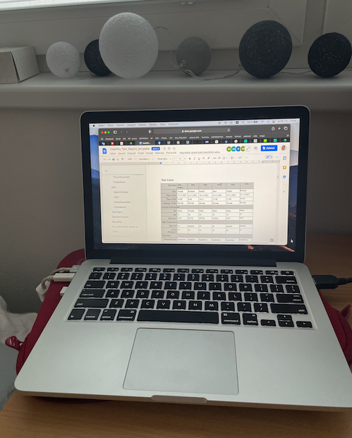**TP1**

**TP2**

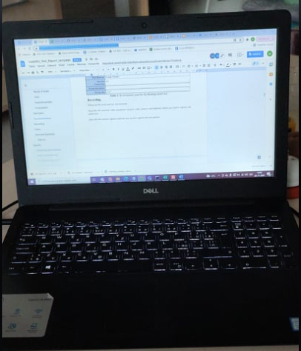

**TP3**

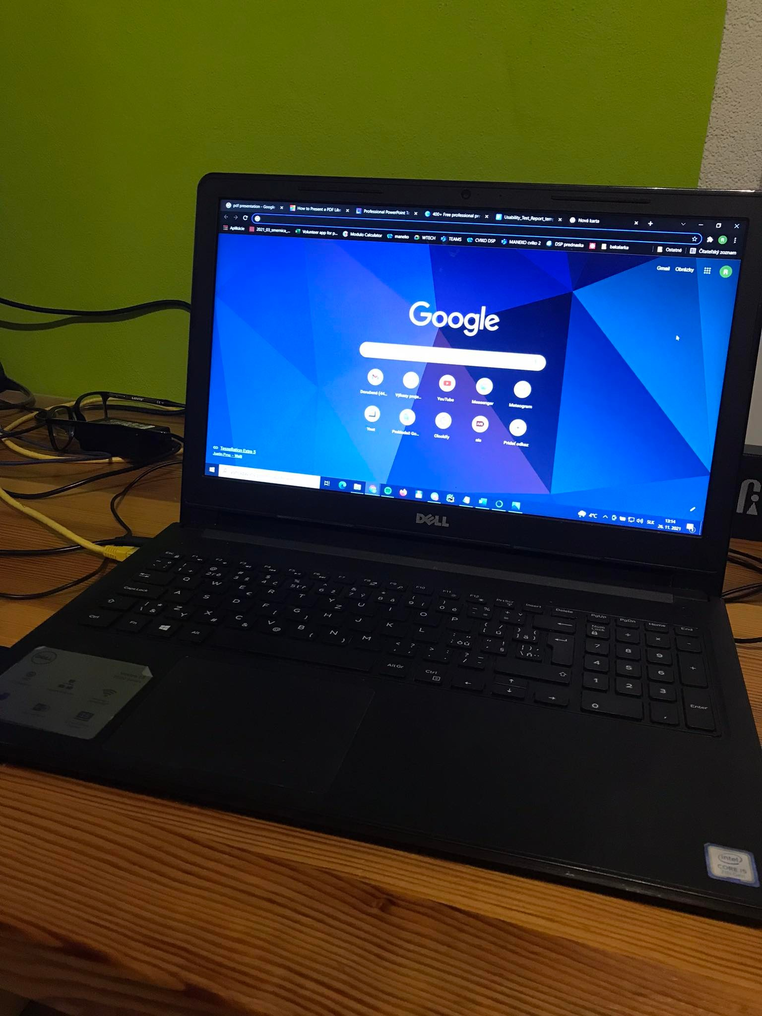

**TP4**

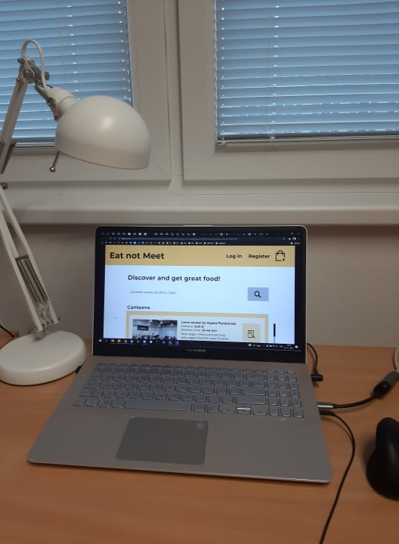

**TP5**

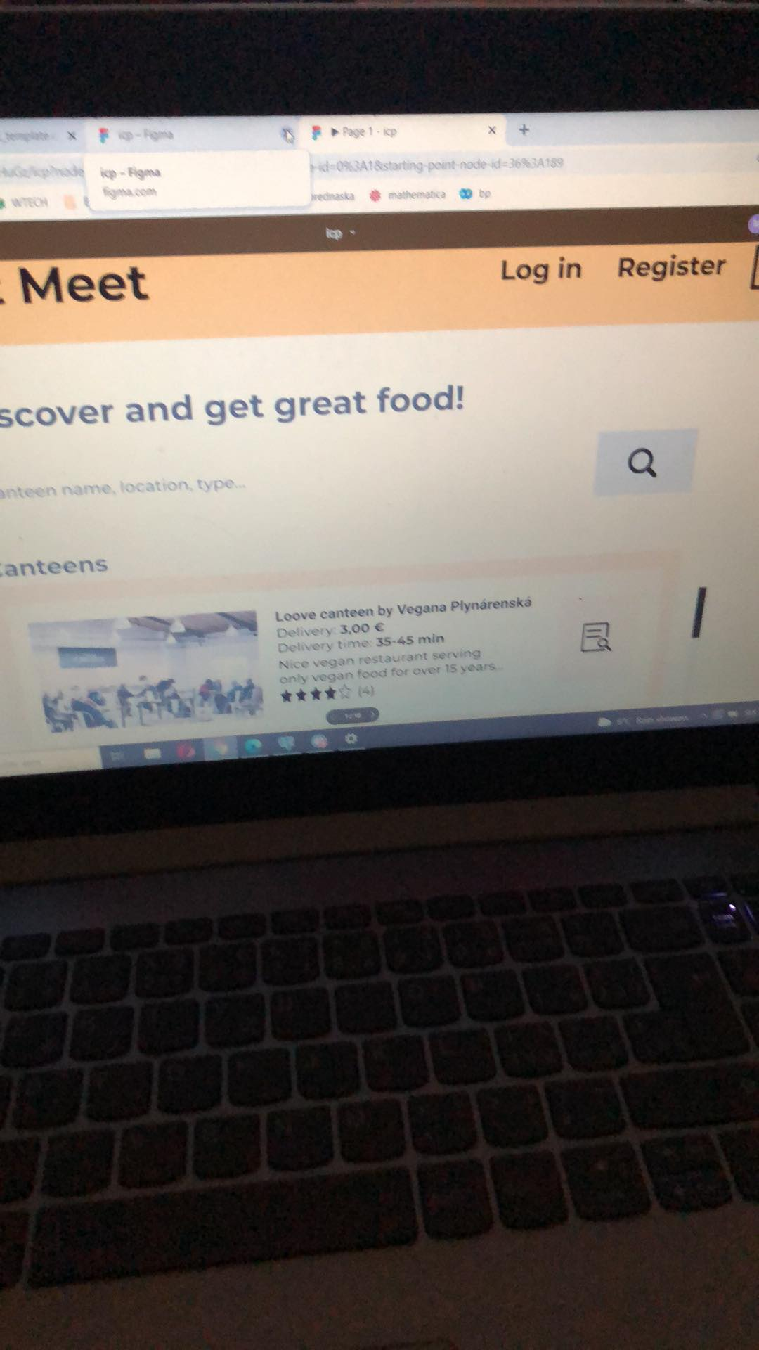

### For capturing the results we all used *OBS Studio* software for recording the screen while testing. For recording the sound we used our cell phone voice recorders.

### **Tasks**

**The task** list used by the test team is shown in Table 3**.   
Only the description of each task is given to the users.**

| **Task No.** | **Description** | **Prerequisites** | **Completion Criteria** | **Max. Time** | **Possible Solution Path** |
| --- | --- | --- | --- | --- | --- |
| 1 | [Impressions]  Please go to the web site:  *eatnotmeet.com*  and spend a few minutes looking around. | Web browser opened at  *eatnotmeet.com* homepage | User indicates they have finished looking around or time has elapsed.  The facilitator then asks the user questions:   1. Whom is this website intended for? 2. What does this website offer? | 1 minute |  |
| 2 | [Motivational]  Please go to the web site:  *eatnotmeet.com*  List some meals available in any of the canteens. | Web browser opened at  *eatnotmeet.com* homepage. | User indicates they have finished looking around or time has elapsed.  The facilitator then asks the user questions:   1. How did you like the place? | 2 minutes | Homepage  -> Click on the listing detail of a canteen from the list of canteens. |
| 3 | Register as user | Web browser opened at *eatnotmeet.com* homepage. | User sees a confirmation dialog about the registration.  The facilitator then asks the user questions:   1. How hard was it to register? | 2 minutes | Home  -> Click on Register  -> Fill in information  -> Click register button  -> Go to my account |
| 4 | Order a meal as unregistered user | Web browser opened at eatnotmeet.com homepage. | User sees a confirmation dialog about the order.  The facilitator then asks the user questions:   1. How hard was it to make the order? 2. Would you recommend the application for ordering the food? | 3 minutes | Home  -> Click on a canteen from canteens list  -> Choose a meal and add it to cart  -> Go to cart  -> Click continue  -> Fill in information -> Click confirm  -> Fill in payment information  -> Click confirm and pay |
| 5 | Register as courier | Web browser opened at *eatnotmeet.com* homepage. | User sees a confirmation dialog about the registration.  The facilitator then asks the user questions:   1. How hard was it to register as a courier? 2. How hard was it to find courier registration? | 3 minutes | Homepage  -> Click on a More info button  -> Click on a Start registration button  -> Fill in information -> Click confirm  -> Go to my account |
| 6 | Order a meal from a list of your favourite meals | Web browser opened at *eatnotmeet.com* homepage.  User is logged into his personal account. | User sees confirmation of the meal order.  The facilitator then asks the user questions:   1. How hard was it to order the meal? 2. How hard was it to look up the list of your favourite meals? | 3 minutes | Homepage  -> Go to my account  -> Click on Favourite meals  -> Click on Order again and add it to cart  -> Go to cart  -> Click continue  -> Click confirm -> Click confirm and pay |
| 7 | Find which orders you have to deliver | Web browser opened at eatnotmeet.com homepage.  Courier is logged into his personal account. | User sees the list of his active orders to deliver.  The facilitator then asks the user questions:   1. Could you easily find your active orders? 2. Would you recommend the application as a job opportunity for potential couriers? | 2 minutes | Home  -> Click on a my account in menu  -> Clink on my active orders in my account |

**Table 3:** Task list.

### **Interview Questions**

1. What difficulties did you have with orientation in the app?
2. How did you find the appearance of the application?
3. How would you describe your experience with the courier registration process?
4. Which parts of the application did you find confusing or frustrating?
5. What did you like the most about the application?
6. What did you like the least about the application?
7. At what part of the application would you appreciate additional information?
8. Would you appreciate any other registration option, if yes what option would it be?
9. What changes would you suggest to make in the app?

**Metrics**

**Completion rate:** Every task except Task 5 and Task 7 was completed without problems. While completing Task 5, respondents were confused, because they could not find the right registration form without assistance. TP4 failed to complete the task, TP3 needed assistance. During Task 7, participants felt confused because of unclear labeling. TP1 could not finish the task, TP0 needed assistance.

**Completion time:** Speaking about completion time, all tasks were completed within a given time. Some of the test users had more computer skills, so they were able to complete the tasks faster than inexperienced ones. Task 4 took the longest to complete, because it was the most complex scenario with lots of steps.

**Feedback questionnaire**: The visual page of the application was rated the best, along with navigation in the user profile. Testers mostly considered that the design of the app is really nice and colour combination was also considered satisfying. Several testers also said that they would recommend the application mainly due to the appearance. The payment process was rated slightly worse since some of the users did not feel comfortable when entering their credit card details. The testers mostly compared the ordering of meals with sites such as wolt or bistro.sk, while they considered the ordering process to be approximately equally satisfactory. Finally, several testers considered it appropriate to add more information about the courier service, such as salary.

## **Results**

### **Discussion and Analysis**

During the testing we found out that correct labeling is very important for user orientation. At first, the purpose of the application was unclear for some users. Some testers were confused about the labeling in courriers account and one of them was not able to accomplish the task to navigate tothe courier's active orders. Two of the users had problems with courier registration. Some of the users would also appreciate more additional information about restaurants (such as opening hours), about job as a courier (salary information) and were also missing some features at the application homepage (map of canteens, search with time indication, filter by price). We also identified user’s uncertainty about payment - giving card information appeared unsafe for them and they would also appreciate more payment options (eg. Apple pay). When talking about login options, they would be likely to use twitter, slack, apple or university account for registration.

### **Task Completion rate**

|  | **Task 1** | **Task 2** | **Task 3** | **Task 4** | **Task 5** | **Task 6** | **Task 7** |
| --- | --- | --- | --- | --- | --- | --- | --- |
| **TP0** | 1 | 1 | 1 | 1 | 1 | 1 | 0.5 |
| **TP1** | 1 | 1 | 1 | 1 | 1 | 1 | 0 |
| **TP2** | 1 | 1 | 1 | 1 | 1 | 1 | 1 |
| **TP3** | 1 | 1 | 1 | 1 | 0.5 | 1 | 1 |
| **TP4** | 1 | 1 | 1 | 1 | 0 | 1 | 1 |
| **TP5** | 1 | 1 | 1 | 1 | 1 | 1 | 1 |
| **%** | **100** | **100** | **100** | **100** | **75** | **100** | **75** |

**Table 5:** Task completion rates ( 0 - not completed, 1- completed, *0.5 - assistance was given*.)

### **Task Completion time**

### *Time measured in seconds*

|  | **Task 1** | **Task 2** | **Task 3** | **Task 4** | **Task 5** | **Task 6** | **Task 7** |
| --- | --- | --- | --- | --- | --- | --- | --- |
| **TP0** | 60 | 7 | 5 | 27 | 14 | 11 | 20 |
| **TP1** | 60 | 11 | 15 | 50 | 8 | 22 | 11 |
| **TP2** | 60 | 39 | 16 | 40 | 20 | 11 | 4 |
| **TP3** | 60 | 20 | 20 | 60 | 25 | 15 | 15 |
| **TP4** | 60 | 41 | 22 | 48 | 35 | 27 | 31 |
| **TP5** | 60 | 6 | 11 | 25 | 30 | 8 | 10 |
| **Avg** | 60 | 20,6 | 14,83 | 41,66 | 22 | 15,16 | 15,16 |
| **Std** | 0 | 14,41 | 5,63 | 12,52 | 9,18 | 6,73 | 8,59 |

**Table 6:** Task completion time

### **User Interviews - answers to the facilitator**

| **TP0** | No problems with orientation. |
| --- | --- |
| **TP1** | No. |
| **TP2** | No. |
| **TP3** | No problem with orientation. |
| **TP4** | I had no problems, orientation was fine. Only issue was when I wanted to find where to register as a courier. |
| **TP5** | None. |

**Table 7a:** User responses to the question 1:   
What difficulties did you have with orientation in the app?

| **TP0** | Very nice appearance and minimalistic design. |
| --- | --- |
| **TP1** | Very nice. |
| **TP2** | Site is too big, but the appearance is nice. |
| **TP3** | I really liked the color combination and minimalistic design. |
| **TP4** | It’s very pretty. |
| **TP5** | Nice layout. |

**Table 7b:** User responses to the question 2:   
How did you find the appearance of the application?

| **TP0** | Very intuitive, registration directly from the homepage. |
| --- | --- |
| **TP1** | Good experience, I would be likely to use it in the future. |
| **TP2** | I would recommend adding courier registration also somewhere else, eg. in the footer. |
| **TP3** | Firstly I was looking for courier registration in the menu but after I noticed a banner on the homepage everything worked properly. |
| **TP4** | It was a bit hard to find the right registration form, otherwise it was fine. |
| **TP5** | It was not very clear, I expected it to be included in the register page. |

**Table 7c:** User responses to the question 3:   
How would you describe your experience with the courier registration process?

| **TP0** | Courier navigation - labels My orders and Orders to deliver were confusing. |
| --- | --- |
| **TP1** | Confusing labeling - My personal orders and All orders to deliver. |
| **TP2** | Confusing labeling - My personal orders and All orders to deliver. I would also add more information about orders, like time of delivery. I would change the favourite meals tab to include favourite canteens. |
| **TP3** | I was not able to find registration in courier menu at first attempt. |
| **TP4** | Registration - it wasn’t very clear where to find courier registration. |
| **TP5** | I could not find a way to get to the canteen page at first. Also, the courier registration was hard to find. |

**Table 7d:** User responses to the question 4:   
Which parts of the application did you find confusing or frustrating?

| **TP0** | Simple navigation, a few clicks lead to directly accomplish the tasks. |
| --- | --- |
| **TP1** | Simple and understandable. |
| **TP2** | Simple and well arranged, clear design. |
| **TP3** | Design. |
| **TP4** | I liked the appearance, it stood out to me the most. |
| **TP5** | I liked the layout and registration form. |

**Table 7e:** User responses to the question 5:   
What did you like the most about the application?

| **TP0** | Missing the link directly to personal order after adding the food to the cart. |
| --- | --- |
| **TP1** | Nothing. I didn’t receive the food I ordered (haha). |
| **TP2** | Harder access to courier registration, too little information about orders for couriers. |
| **TP3** | Unclear access to courier registration. |
| **TP4** | The courier registration was hard to find. |
| **TP5** | Hard access to courier registration. |

**Table 7f:** User responses to the question 6:   
What did you like the least about the application?

| **TP0** | No idea. |
| --- | --- |
| **TP1** | About a courier job (more additional info about payment). |
| **TP2** | Orders for couriers, about a courier job. |
| **TP3** | Maybe more information about salary for courier. |
| **TP4** | I didn’t need any additional info, everything was pretty clear to me. |
| **TP5** | More info about canteens in the canteen list. |

**Table 7g:** User responses to the question 7:   
At what part of the application would you appreciate additional information?

| **TP0** | Apple login. |
| --- | --- |
| **TP1** | No, provided options are enough. |
| **TP2** | Maybe by university account, apple login. |
| **TP3** | Slack. |
| **TP4** | No, for me it was enough options. Maybe for other people login via Twitter. |
| **TP5** | No, there were enough options for me. |

**Table 7h:** User responses to the question 8:   
Would you appreciate any other registration option, if yes what option would it be?

| **TP0** | Direct link to personal order after adding the food into the cart. |
| --- | --- |
| **TP1** | No. |
| **TP2** | Adding map to canteen search with wait time indication, filter by price, wait time…  Adding popup with active order information, writing card info appears unsafe for me, I would make in another, secure window, I miss more legal information about the job. |
| **TP3** | No. |
| **TP4** | I would suggest putting links to user and courier registration next to each other to make it easier to find them both. |
| **TP5** | I would put the link to courier registration at least in the footer. |

**Table 7i:** User responses to the question 9:   
What changes would you suggest to make in the app?

### **Feedback Questionnaires**

Table 7 shows a summary of the ratings given by users in the feedback questionnaire at the end of the test. The neutral scale in the original feedback questionnaire has been mapped to a weighted scale between 6 (best) and 0 (worst)

|  |  |  |  |  | **TP0** | **TP1** | **TP2** | **TP3** | **TP4** | **TP5** | **Mean** | **Std. Dev** |
| --- | --- | --- | --- | --- | --- | --- | --- | --- | --- | --- | --- | --- |
| 1. | Did you like the visual part of the app? | A lot | 6   5   4   3   2   1   0 | Not at all | 6 | 6 | 6 | 6 | 6 | 6 | 6 | 0 |
| 2. | Was the navigation in your personal profile easy to use? | Very easy | 6   5   4  3   2   1   0 | Very hard | 6 | 6 | 6 | 6 | 6 | 6 | 6 | 0 |
| 3. | Did you find food ordering process  easier compared to similar applications? | Much easier | 6   5   4  3   2   1   0 | Much harder | 5 | 6 | 6 | 3 | 4 | 3 | 4,5 | 1,26 |
| 4. | Did you find the payment process comfortable? | Very comfortable | 6   5  4  3   2   1   0 | Very uncomfortable | 6 | 6 | 3 | 5 | 6 | 5 | 5,17 | 1,07 |
| 5. | Did you find all necessary information about courier service? | Absolutely | 6   5   4  3   2   1   0 | Not at all | 6 | 5 | 5 | 3 | 3 | 2 | 4 | 1,41 |
| 6. | Would you use this site instead of other sites providing food delivery? | Very likely | 6   5   4  3   2   1   0 | Very unlikely | 5 | 6 | 5 | 6 | 3 | 5 | 5 | 1 |
| 7. | How likely are you to recommend this app? | Very likely | 6   5   4  3   2   1   0 | Very unlikely | 5 | 6 | 5 | 6 | 5 | 6 | 5,5 | 0,5 |

**Table 8:** Summary of user ratings from the feedback questionnaire.

### **List of Problems Found**

1. *Find a list of my orders to deliver in a courier account.*Users struggled to find the list of orders to deliver after logging into their courier account. They were confused about the labels *My personal orders* and *All orders to deliver*.
2. *Register as courier*Users couldn’t find the right form for registration as a courier, so they started filling out the wrong registration form as a user.
3. *Payment options*Users would like to have more than one current option to pay for their orders. They felt like card payment isn’t always the safest option.
4. *Additional information about courier position*  
   Participants would appreciate more information about current courier position, e.g. wage info, legal documents...
5. *Additional information about canteens*Testers were missing some information about canteens, e.g. opening hours, location and map.
6. *Purpose of the application*  
   Participants didn’t understand the purpose of the application. They recognised that the site is providing food delivery services, but not that it is mostly aimed for students at dormitories.
7. *Login options*Users would like to have more options for login - Twitter, Slack, Apple login, University account...
8. **Transcripts**

### **TP1**

**Testing**

*-Try to list some meals available in any of the canteens.*

-This is a canteen?

*-Yes, well done, the next task is:Try to register as a user*

- (Hovers over Facebook registration) This?

*-However you want. (...) Now try to order the food as an unregistered user.*

*-* (Tries to click on the image of the canteen) Why can’t I click on it?

*- The next task is: register as a courier, (...) well done this was very fast.*

- I noticed it at the beginning of the testing. (haha)

*- Try to order some of your favourite meals. (...) Great, the last task is: As a registered courier, try to look up the orders you have to deliver*

- (Opens all available orders and waits)

*-Try to look up your personal orders*

- I don’t understand the task, what’s wrong with this page?

*- Okay, that’s all.*

**Task 1 - Impressions**

1. Whom is this website intended for?  
   - For everyone who wants to order food.
2. What does this website offer?  
   - Food delivery.

**Task 2 - Motivational task**

1. How did you like the place?  
   - It is in English, I really like that. And the design is beautiful.

**Task 3 - Register as user**

1. How hard was it to register?  
   Very easy and intuitive.

**Task 4 - Order a meal as unregistered user**

1. How hard was it to make the order?  
   I had no problems.
2. Would you recommend the application for ordering the food?  
   Yes I think ordering is simpler than on other platforms.

**Task 5 - Register as courier**

1. How hard was it to register as a courier?  
   Very easy, almost as a user registration.
2. How hard was it to find courier registration?  
   For me it was very easy, I noticed courier registration at the beginning of the testing at homepage.

**Task 6 - Order a meal from a list of your favourite meals**

1. How hard was it to order the meal?  
   At first I couldn’t click on the canteen. But ordering and payment went without any problems.
2. How hard was it to look up the list of your favourite meals?  
   Easy, just a few clicks.

**Task 7 - Find which orders you have to deliver**

1. Could you easily find your active orders?   
   No I was confused by the labeling, I thought I accomplished the task but no.
2. Would you recommend the application as a job opportunity for potential couriers?  
   Yes I personally would like to get a job like this.

**Interview Questions**

1. What difficulties did you have with orientation in the app?   
   No problems with orientation.
2. How did you find the appearance of the application?  
   Very nice.
3. How would you describe your experience with the courier registration process?  
   Good experience, I would be likely to use it in the future.
4. Which parts of the application did you find confusing or frustrating?  
   I found the labeling a bit confusing, especially in the courier account, the task about personal orders...
5. What did you like the most about the application?  
   It is simple and understandable.
6. What did you like the least about the application?  
   Nothing. I didn’t receive the food I ordered (haha).
7. At what part of the application would you appreciate additional information?  
   About a courier job. I would appreciate more additional information about payment.
8. Would you appreciate any other registration option, if yes what option would it be?  
   No, provided options are enough.
9. What changes would you suggest making in the app?  
   No idea.

**TP2**

**Testing tasks:**

**Task 1 - Impressions**

1. Whom is this website intended for?  
   For students.
2. What does this website offer?  
   Food delivery and job.

**Task 2 - Motivational task**

1. How did you like the place?  
   Really nice color scheme and design.

**Task 3 - Register as user**

1. How hard was it to register?  
   It went easily.

**Task 4 - Order a meal as unregistered user**

1. How hard was it to make the order?  
   Everything was clear and easy to find, so it went well.
2. Would you recommend the application for ordering the food?  
   Yes, it seems to be easy to order from here.

**Task 5 - Register as courier**

1. How hard was it to register as a courier?  
   I could not find where to register at first, but when I found it, it was easy.
2. How hard was it to find courier registration?  
   It was a little bit confusing, because firstly I clicked on the register button, but it was just registration for a user. Then I found it on the homepage.

**Task 6 - Order a meal from a list of your favourite meals**

1. How hard was it to order the meal?  
   Easy, just putting food to the cart and doing all necessary steps to finish order.
2. How hard was it to look up the list of your favourite meals?  
   Not hard at all.

**Task 7 - Find which orders you have to deliver**

1. Could you easily find your active orders?   
   I was a bit confused by the labeling, but then I found it.
2. Would you recommend the application as a job opportunity for potential couriers?  
   Maybe yes, it depends on the salary.

**Interview Questions**

1. What difficulties did you have with orientation in the app?   
   I had no problems with orientation.
2. How did you find the appearance of the application?  
   It was really nice, well balanced colours and nice design.
3. How would you describe your experience with the courier registration process?  
   I was struggling with finding the right registration, got a bit confused, but then I found the right form and everything was clear. Would recommend adding courier registration to the footer.
4. Which parts of the application did you find confusing or frustrating?  
   Little confusing labeling in courier profile, I would also add favourite canteens tab, where I would be able to find my liked places.
5. What did you like the most about the application?  
   The site has a simple, well arranged design, almost everything was easy to find.
6. What did you like the least about the application?  
   Hard access to the courier registration.
7. At what part of the application would you appreciate additional information?  
   Orders for couriers, about courier job.
8. Would you appreciate any other registration option, if yes what option would it be?  
   Maybe by university account, apple login.
9. What changes would you suggest making in the app?  
   Adding map to canteen search with wait time indication, filter by price, wait time… Adding popup with active order information, writing card info appears unsafe for me, I would make in another, secure window, I miss more legal information about job

**TP3**

**Testing tasks:**

**Task 1 - Impressions**

1. Whom is this website intended for?  
   I think the website is for students, maybe teachers I suppose.
2. What does this website offer?  
   It offers food delivery.

**Task 2 -Motivational task**

1. How did you like the place?  
   It was nice but I would like to see more food options.

**Task 3 - Register as user**

1. How hard was it to register?  
   It was really easy.

**Task 4 - Order a meal as unregistered user**

1. How hard was it to make the order?  
   Well, I couldn't choose my meals because they were prefilled, so it was easy.
2. Would you recommend the application for ordering the food?  
   Yes, the steps of ordering were really clear.

**Task 5 - Register as courier**

1. How hard was it to register as a courier?  
   Very easy and straightforward.
2. How hard was it to find courier registration?  
   Firstly I clicked on registration in the menu but on second try I found the banner on the home page.

**Task 6 - Order a meal from a list of your favourite meals**

1. How hard was it to order the meal?  
   Same as in food ordering, it was quite simple.
2. How hard was it to look up the list of your favourite meals?  
   It was as I expected in my profile so I found it really fast.

**Task 7 - Find which orders you have to deliver**

1. Could you easily find your active orders?   
   Not really because I have to register first, I was not able to login as a courier straight.
2. Would you recommend the application as a job opportunity for potential couriers?  
   I think yes, but I could see the salary.

**Interview Questions**

1. What difficulties did you have with orientation in the app?   
   I couldn’t find my orders as a courier, because I couldn’t log in as a courier.
2. How did you find the appearance of the application?  
   I liked it, it was quite minimalistic and had nice colours.
3. How would you describe your experience with the courier registration process?  
   I couldn’t find the right registration option.
4. Which parts of the application did you find confusing or frustrating?  
   Finding my account as the courier.
5. What did you like the most about the application?  
   Most of the time it was easy to find what I was looking for, and I really loved design.
6. What did you like the least about the application?  
   As I said, I think I couldn’t log in as a courier.
7. At what part of the application would you appreciate additional information?  
   In courier registration.
8. Would you appreciate any other registration option, if yes what option would it be?  
   I think this is enough.
9. What changes would you suggest making in the app?  
   I would add an option to register and log in as a courier from the top bar menu.

**TP4**

**Testing tasks:**

**Task 1 - Impressions**

1. Whom is this website intended for?  
   - I guess for anyone who wants to order food.  
   Can you be more specific?   
   - No. This is what I understood from browsing the app.
2. What does this website offer?  
   Food delivery service and I think I saw an option to get a job also. I’m not sure.

**Task 2 - Motivational task**

1. How did you like the place?  
   - Yes.  
   How would you describe this experience?  
   - It was fine I guess.  
   Was there anything that was frustrating? Were there any issues?  
   - No, I think I found everything Ineeded.

**Task 3 - Register as user**

1. How hard was it to register?  
   It was pretty easy. Especially easy was finding where to start the registration, I didn’t need to look for anything. Also it’s very convenient that I can register with Facebook.

**Task 4 - Order a meal as unregistered user**

1. How hard was it to make the order?  
   - It was easy.  
   Did you have any issues? Was there anything confusing for you?  
   - I don’t think so. Every step was clear to me, no issues.
2. Would you recommend the application for ordering the food?  
   - Yes, for sure.  
   Why?   
   - It looks nice. I find it very comfortable to use and also food delivery is very convenient.

**Task 5 - Register as courier**

1. How hard was it to register as a courier?  
   I was so confused, I couldn’t do it. Instead I registered as a normal user by mistake.
2. How hard was it to find courier registration?  
   I needed to go to the homepage, I couldn’t just click on the registration button up here. That was very confusing that I couldn't find the registration under the button that says registration.

**Task 6 - Order a meal from a list of your favourite meals**

1. How hard was it to order the meal?  
   Pretty easy, no issues.
2. How hard was it to look up the list of your favourite meals?  
   I had no difficulties, I just clicked on the tab named Favourite meals and added a meal to the cart. After that I just ordered the meal like I did in that previous task. I like that you have the option to save your favourites, that could be quite convenient I think, because I usually just order the same thing over and over again.

**Task 7 - Find which orders you have to deliver**

1. Could you easily find your active orders?   
   - Yes, it was right there in my profile.   
   So there was no confusion? Are you sure about your choice?  
   - No. It said My orders to deliver so I’m sure that was what I was looking for.
2. Would you recommend the application as a job opportunity for potential couriers?  
   I don’t know if I would recommend this to anyone, I’ve never worked as a courier. But I would tell someone who is looking for a job that this opportunity exists.

**Interview Questions**

1. What difficulties did you have with orientation in the app?   
   I had no problems, orientation was fine. Only issue was when I wanted to find where to register as a courier.
2. How did you find the appearance of the application?   
   It’s very pretty. It’s yellow.
3. How would you describe your experience with the courier registration process?  
   It was a bit hard to find the right registration form, otherwise it was fine.
4. Which parts of the application did you find confusing or frustrating?  
   It wasn’t very clear where to find courier registration.
5. What did you like the most about the application?  
   I liked the appearance, it stood out to me the most.
6. What did you like the least about the application?  
   The courier registration was hard to find.
7. At what part of the application would you appreciate additional information?  
   I didn’t need any additional info, everything was pretty clear to me.
8. Would you appreciate any other registration option, if yes what option would it be?  
   No, for me it was enough options. Maybe for other people login via Twitter.
9. What changes would you suggest to make in the app?  
   I would suggest putting links to user and courier registration next to each other to make it easier to find them both.

**TP5**

**Testing tasks:**

**Task 1 - Impressions**

1. Whom is this website intended for?  
   -For people who want to use a food delivery service.
2. What does this website offer?  
   -Possibility to order food.

**Task 2 - Motivational task**

1. How did you like the place?  
   -The colors and layout are really nice.

**Task 3 - Register as user**

1. How hard was it to register?  
   -It was the usual registration process. I’ve done it milion times, so for me it was really easy.

**Task 4 - Order a meal as unregistered user**

1. How hard was it to make the order?  
   -Again it was the process I’m used to from similar applications, there were no complications.
2. Would you recommend the application for ordering the food?  
   -Of course, I think anyone would be able to make an order from this application.

**Task 5 - Register as courier**

1. How hard was it to register as a courier?  
   -After finding the right button it was painless, but searching for the button took me some time. First I thought the courier registration can be found under the same link as normal registration, but that was not true and I found that confusing. Another place where I expected to find the courier registration link was the application footer, but I wasn’t lucky there either. Finally I glimpsed the courier registration button on homepage and was able to proceed with the registration.
2. How hard was it to find courier registration?  
   -I think I answered this question before, it was difficult.

**Task 6 - Order a meal from a list of your favourite meals**

1. How hard was it to order the meal?  
   -It was pretty easy.
2. How hard was it to look up the list of your favourite meals?  
   -No troubles as well, it was where I expected it to be.

**Task 7 - Find which orders you have to deliver**

1. Could you easily find your active orders?   
   -Yes, it was easy.
2. Would you recommend the application as a job opportunity for potential couriers?  
   -Probably yes, maybe it would be good to see more information about the job first.

**Interview Questions**

1. What difficulties did you have with orientation in the app?

-None.

1. How did you find the appearance of the application?

-Nice layout.

1. How would you describe your experience with the courier registration process?

-It was not very clear, I expected it to be included in the register page.

1. Which parts of the application did you find confusing or frustrating?

-I could not find a way to get to the canteen page at first. Also, the courier registration was hard to find.

1. What did you like the most about the application?

-I liked the layout and registration form.

1. What did you like the least about the application?

-Hard access to courier registration.

1. At what part of the application would you appreciate additional information?

-More info about canteens in the canteen list.

1. Would you appreciate any other registration option, if yes what option would it be?

-No, there were enough options for me.

1. What changes would you suggest to make in the app?

-I would put the link to courier registration at least in the footer.

# 

# 

# **4 Mobile Design Phase**

## **4.1 Low-Fidelity Mobile Design**

HOME PAGE FAVOURITE MEALS

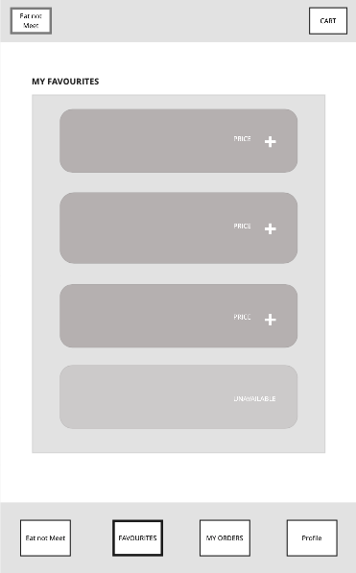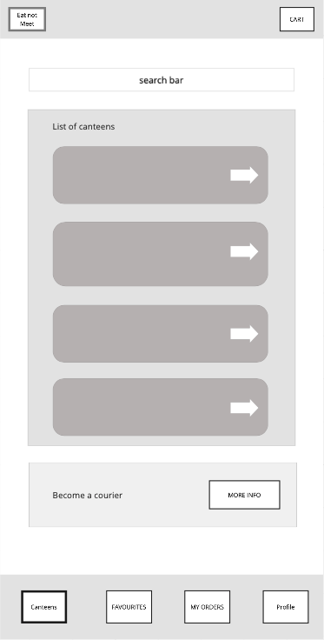

CART ORDER CONFIRMATION

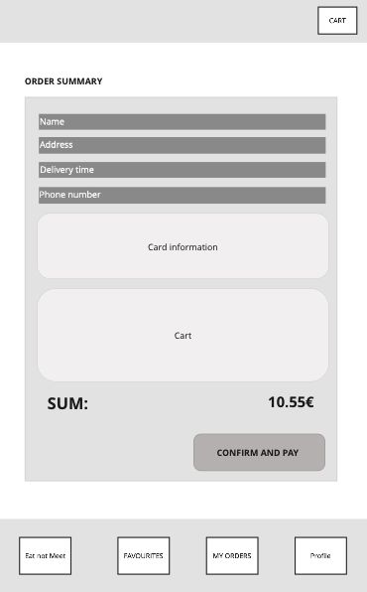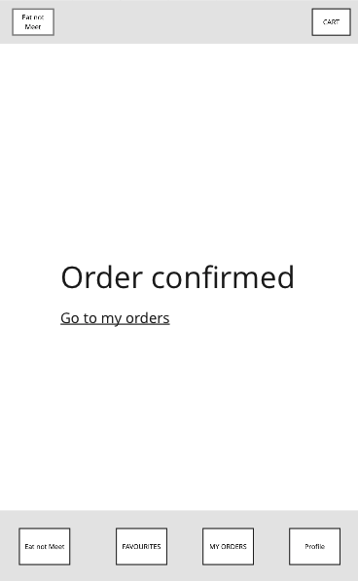

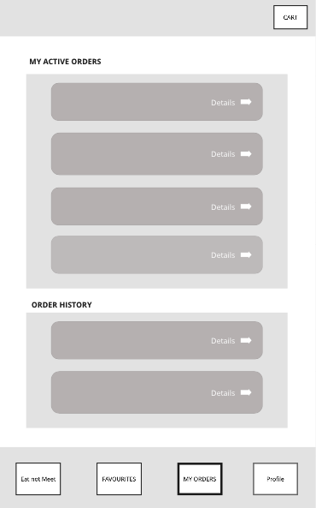MY ORDERS

## **4.2 High-Fidelity Mobile Design**

## 

## **4.3 Usability Testing of Mobile Design**

# **Usability Test Report of Mobile Design**

### **Name of tested web/application**

Eat not meet

### **Place, date**

Bratislava  
29.11.2021 - 05. 12. 2021

## **Summary**

1. No option to save credit card information.  
   We would solve this problem by adding an option to save credit card information.
2. Unnecessary buttons in favourite foods screen.  
   We would solve this problem by replacing the remove button with a cross on the top left part of the picture of the food, just like in the cart.
3. **Test Procedure Description**

### **User Profiles**

### **DUŠAN**

**Age:** 22

**Location:** Bratislava

**Job:** Študent informatiky

**Bio:** Študent informatiky, ktorý momentálne býva na internáte ŠD Mladosť. Má rád dobré jedlo, avšak väčšinu času trávi vo svojej izbe. Je veľmi vyťažený štúdiom a čas, ktorý trávi cestou do jedálne a čakaním v rade by vedel zužitkovať lepšie.

**Needs & Goals:**

- Možnosť jedenia bez sociálnej interakcie a zbytočného pohybu.

- Lacné stravovanie.

**Tech:**

Internet 5/5

Social media 1/5

Online shopping 5/5

**Favourite portals:**

askalot.sk

eat&meet.sk

stackoverflow.com

**Frustrations:**

- Donáškové služby sú predražené.

- Preplnená jedáleň.

### **ALICA**

**Age:** 21

**Location:** Bratislava

**Job:** Študentka filozofie

**Bio:** Študentka filozofie, ktorá momentálne býva na internáte Šturák. Vo voľnom čase sa venuje predaju esenciálnych olejov. Je vegánka. Napriek momentálnej pandemickej situácii nie je očkovaná. To jej značne sťažuje prístup do stravovacích zariadení.

**Needs & Goals:**

- Možnosť jedenia bez testu/očkovania.

- Zdravé, vegánske a cenovo dostupné stravovanie.

**Tech:**

Internet 3/5

Social media 5/5

Online shopping 4/5

**Favourite portals:**

zemavek.sk

zdraveoleje.sk

instagram.com

**Frustrations:**

- Potreba testu/očkovania do jedálne.

- Slabý výber vegánskych, cenovo dostupných jedál.

### **BRAŇO**

**Age:** 25

**Location:** Bratislava

**Job:** Študent FTVŠ

**Bio:** Študent FTVŠ. Keďže sa venuje športu, potrebuje kvalitnú, ale cenovo dostupnú stravu pre študenta. Takéto možnosti však nemá, pretože v jeho okolí sa nenachádza žiadna študentská jedáleň.

**Needs & Goals:**

- kvalitná, ale cenovo dostupná strava

- možnosť stravovania, za ktorým nemusí ďaleko dochádzať

**Tech:**

Internet 2/5

Social media 3/5

Online shopping 1/5

**Favourite portals:**

zlavomat.sk

nike.sk

**Frustrations:**

- v jeho okolí sa nenachádza žiadna študentská jedáleň

- reštaurácie a donáškové služby sú drahé

### **JANO**

**Age:** 22

**Location:** Bratislava

**Job:** Študent EUBA

**Bio:** Študent na ekonomickej univerzite v Bratislave, ktorý býva na internáte Družba. V jeho okolí sa nenachádza žiadna študentská jedáleň a tak si jedlo varí sám. Pravidelne športuje a istý čas sa zaujímal aj o zdravú výživu.

**Needs & Goals:**

- cenovo dostupná strava

- objednanie jedla na internát

**Tech:**

Internet 3/5

Social media 3/5

Online shopping 2/5

**Favourite portals:**

www.florbal4u.cz

www.aliexpress.com

**Frustrations:**

- drahé potraviny a časovo náročná príprava jedál na internáte

### **Test Users**

| **Test User** | **TP1** | **TP2** | **TP3** | **TP4** | **TP5** |
| --- | --- | --- | --- | --- | --- |
| *Alias* | Karin | Nikoleta | Jano | Dušan | Roman |
| *Date of Test* | 5.12.2021 | 6.12.2021 | 5.12.2021 | 4.12.2021 | 5.12.2021 |
| *Time of Test* | 14:36 | 3:34 | 17:58 | 14:00 | 19:30 |
| *Language of Test* | Slovak | Slovak | Slovak | Slovak | Slovak |
| **General Information** | | | | | |
| *Sex* | Female | Female | Male | Male | Male |
| *Age* | 24 | 22 | 22 | 22 | 22 |
| *Education* | FIIT | FFUK | EUBA | FIIT | FIIT |
| **Sight Impairment** | | | | | |
| *Sight Aid* | glasses | no | no | glasses | glasses |
| *Colour Blindness?* | no | no | no | no | no |
| **Education** | | | | | |
| *Education level* | master’s undergraduate | bachelors undergraduate | bachelors undergraduate | bachelors undergraduate | bachelors undergraduate |

**Table 1:** Overview of the test users.

### **Test Environment**

| **Equipment (TP1)** | |
| --- | --- |
| **Device** | Xiaomi Mi 9 SE |
| **Operating System** | Android |
| **Web Browser** | Google Chrome |
| **Internet Connection** | WiFi |
| **Screen Resolution** | Full HD |
| **Screen Size** | 6.4’’ |
| **Equipment (TP2)** | |
| **Device** | Iphone 12 |
| **Operating System** | iOs 15 |
| **Web Browser** | Safari |
| **Internet Connection** | Wifi |
| **Screen Resolution** | OLED |
| **Screen Size** | 6.1” |
| **Equipment (TP3)** | |
| **Device** | Iphone 7 |
| **Operating System** | iOs 14 |
| **Web Browser** | Safari |
| **Internet Connection** | Wifi |
| **Screen Resolution** | 750x1334 pixels |
| **Screen Size** | 4,7’’ |
| **Equipment (TP4)** | |
| **Device** | Samsung Galaxy A50 |
| **Operating System** | Android 11 |
| **Web Browser** | Samsung Internet Browser |
| **Internet Connection** | Wifi |
| **Screen Resolution** | Full HD |
| **Screen Size** | 6.4’’ |
| **Equipment (TP5)** | |
| **Device** | Iphone 8 |
| **Operating System** | iOS 14.8.1 |
| **Web Browser** | Google Chrome |
| **Internet Connection** | Wifi |
| **Screen Resolution** | Full HD |
| **Screen Size** | 5” |

**Table 2:** Environment used for the thinking aloud test.

### **Test environment**

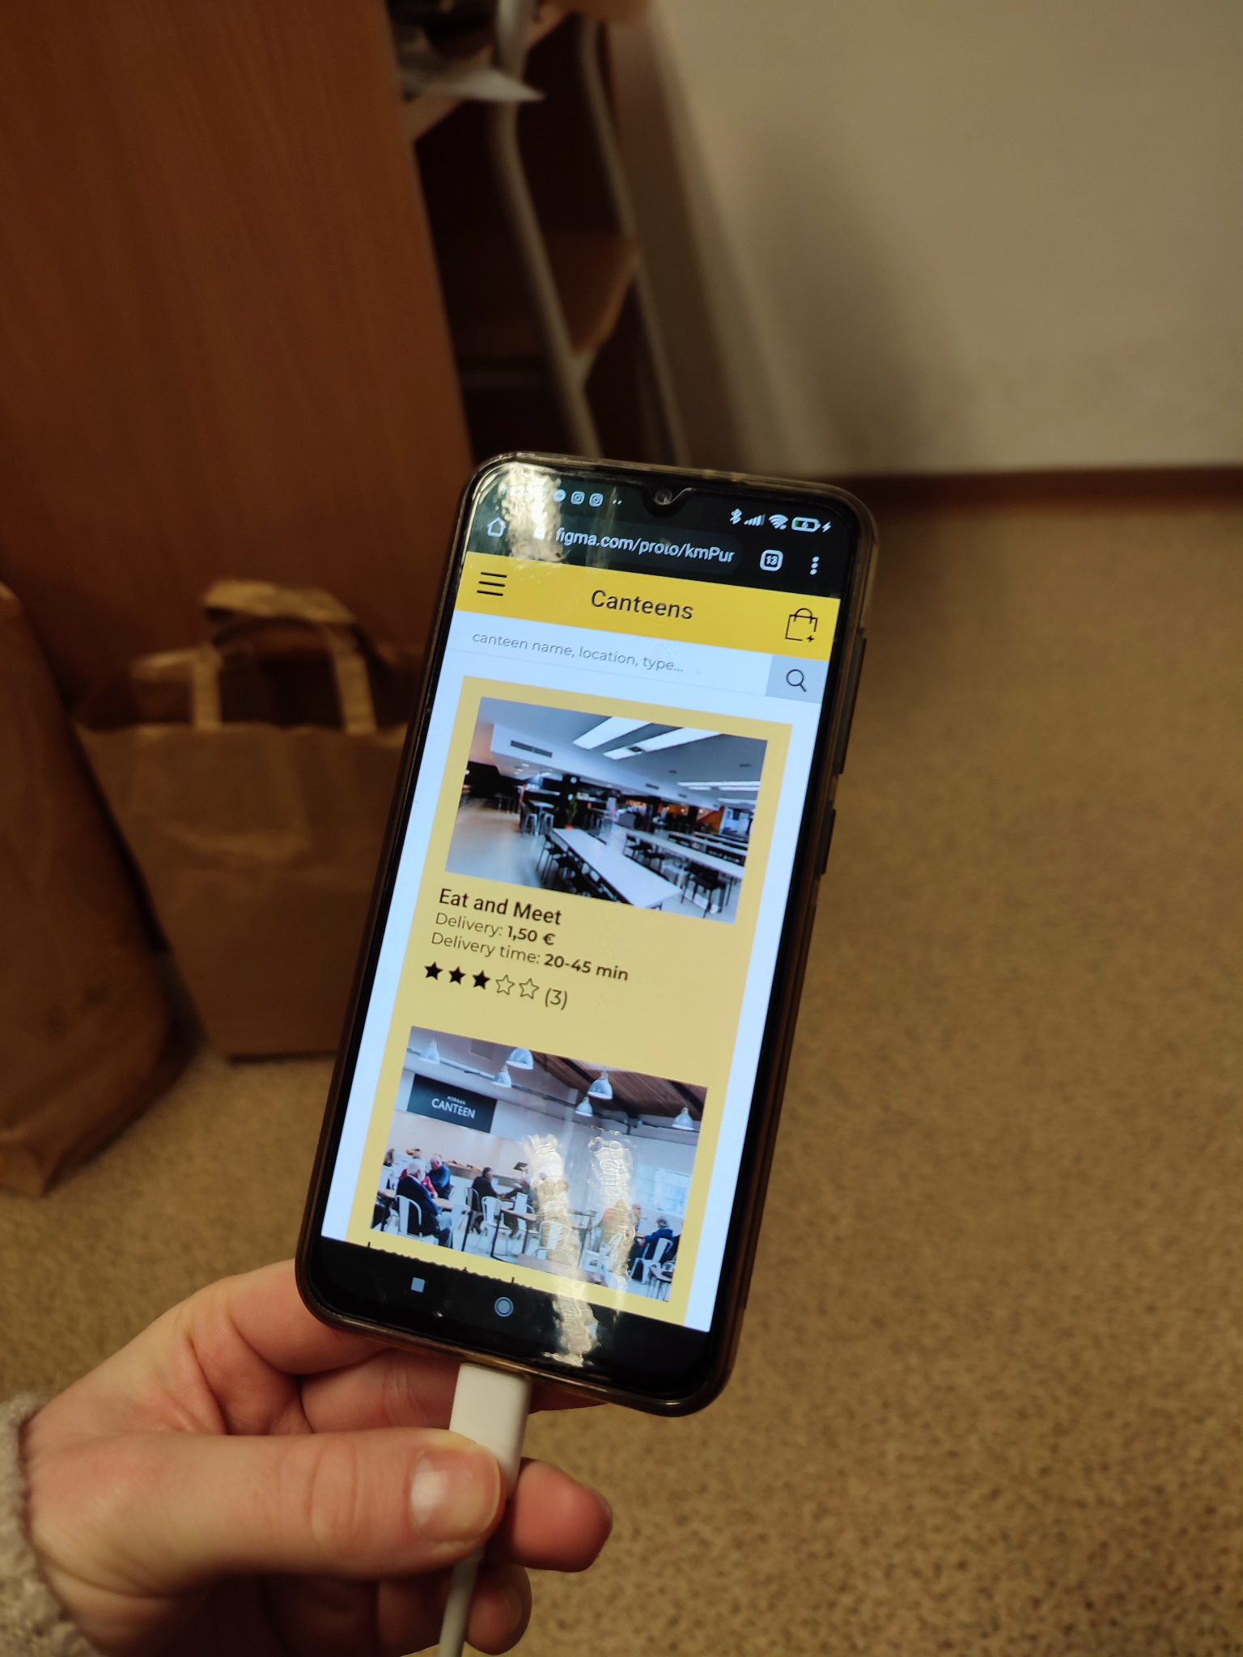**TP1**

**TP2**

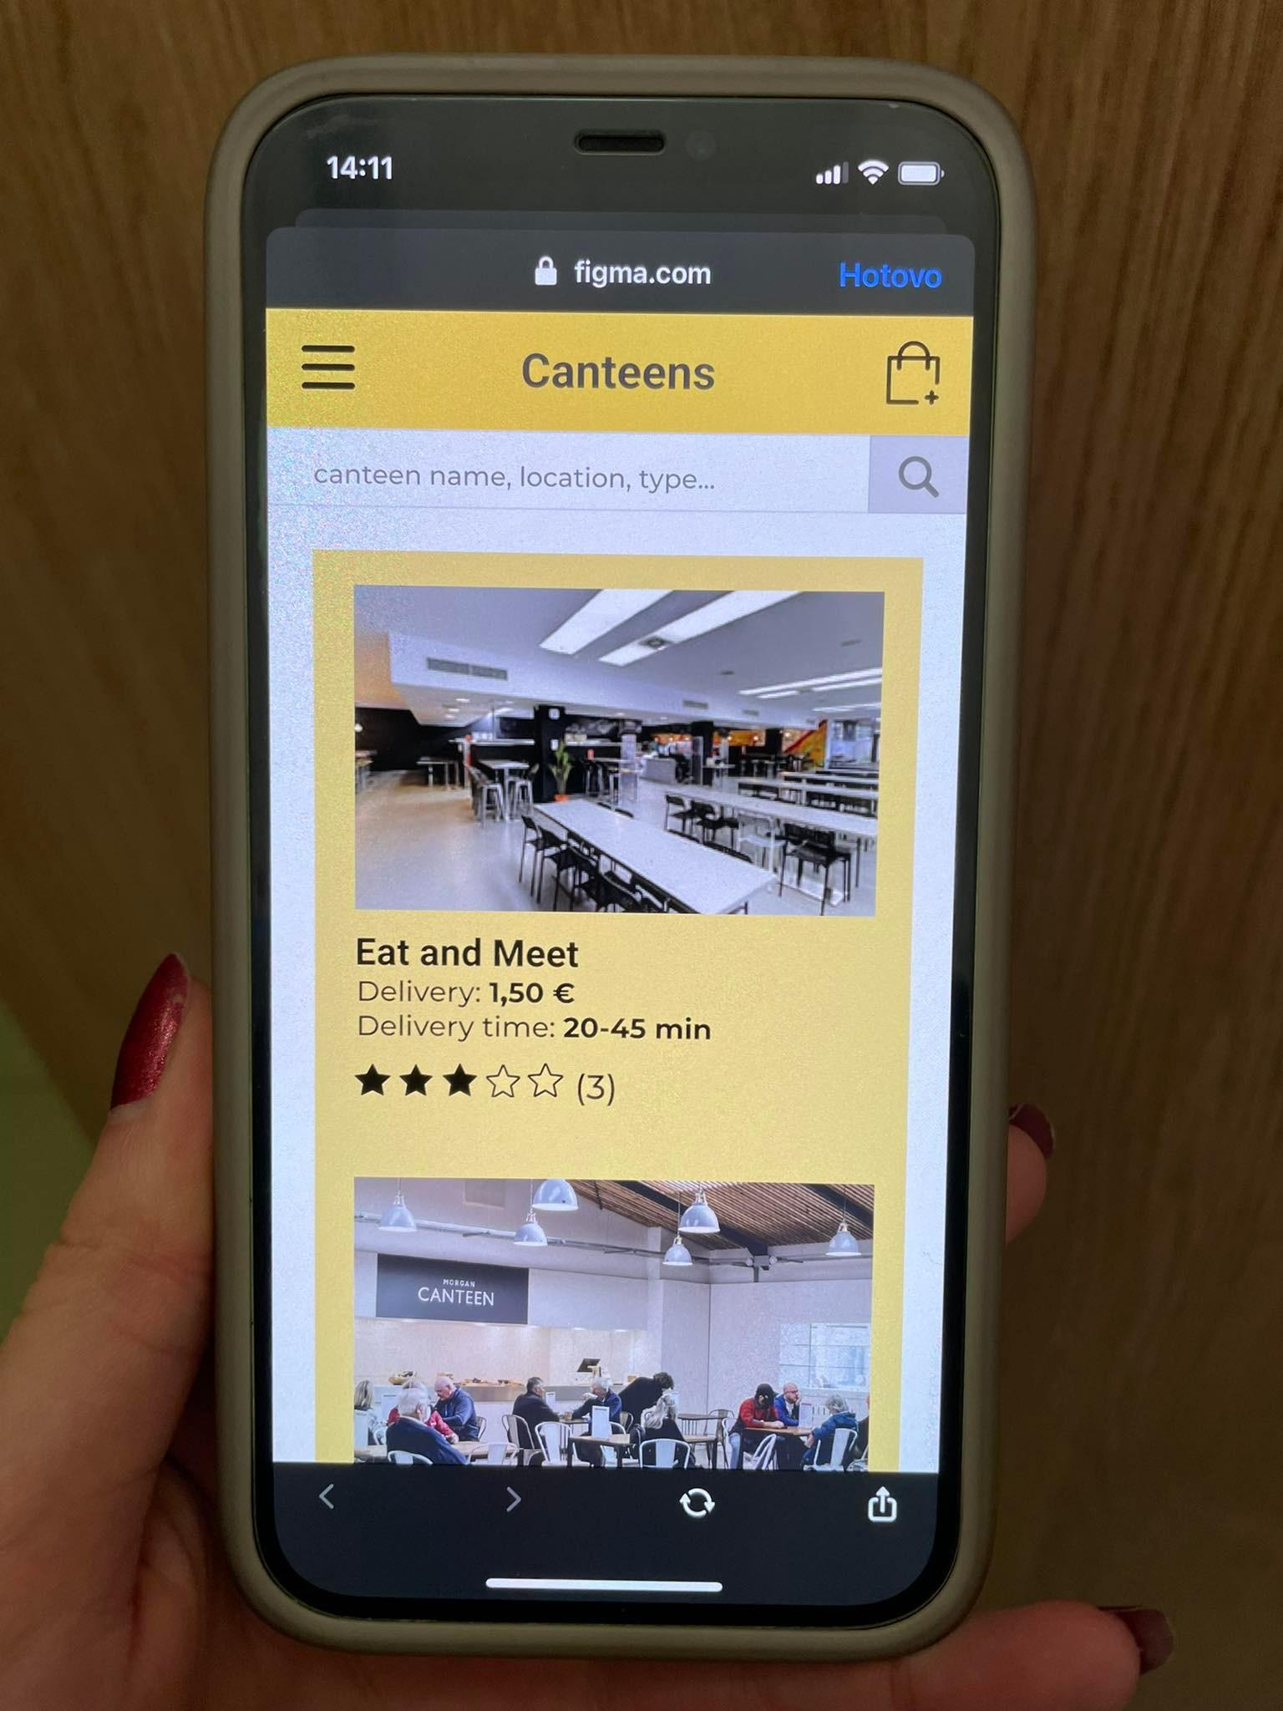

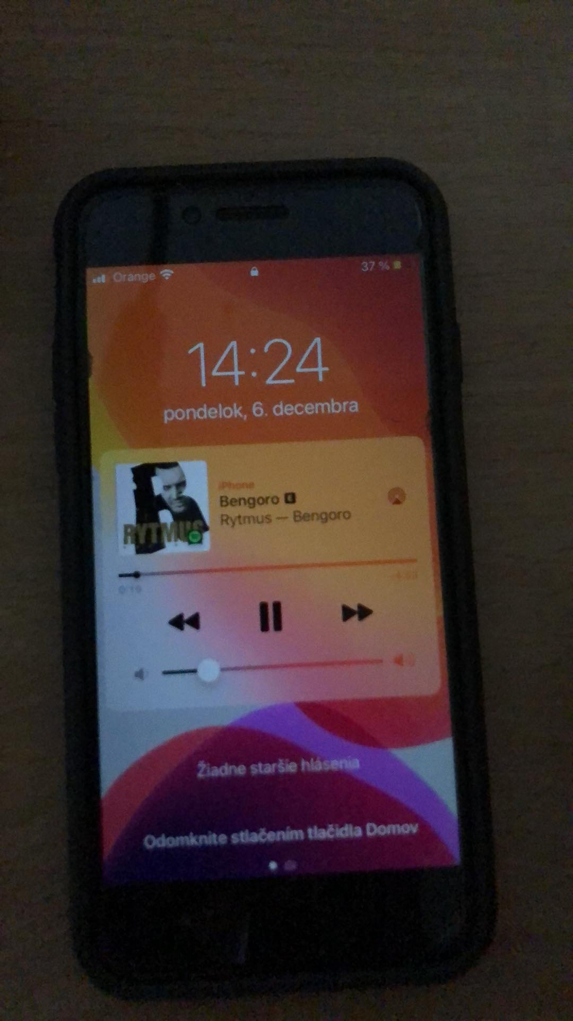**TP3**

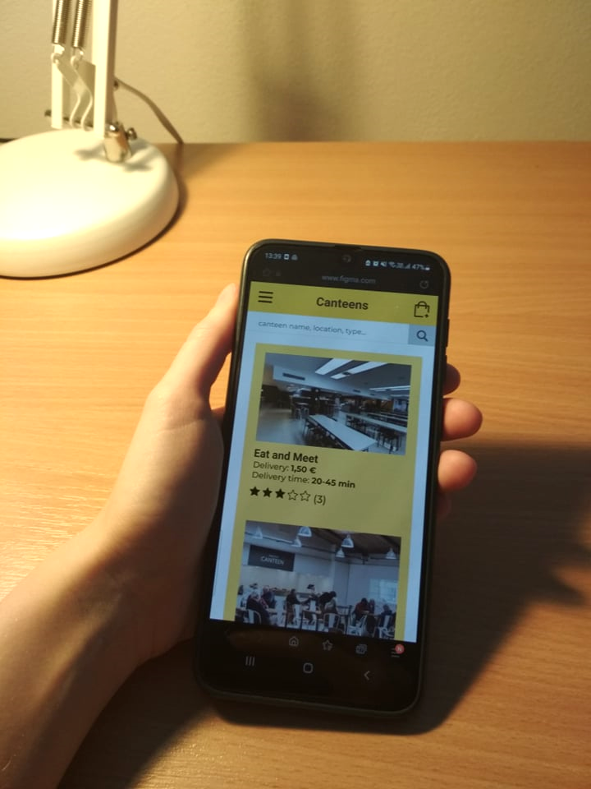**TP4**

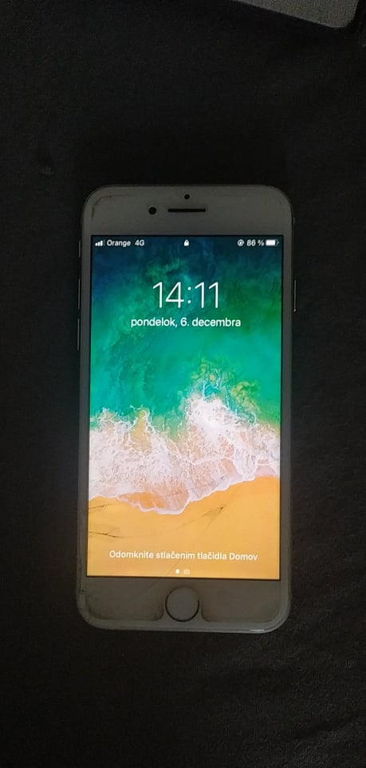**TP5**

### **Tasks**

**The task** list used by the test team is shown in Table 3**.   
Only the description of each task is given to the users.**

| **Task No.** | **Description** | **Prerequisites** | **Completion Criteria** | **Max. Time** | **Possible Solution Path** |
| --- | --- | --- | --- | --- | --- |
| 1 | [Impressions]  Please go to the app:  *Eat not meet*  and spend a few minutes looking around. | Mobile app *Eat not meet* opened at homepage  User is logged into his personal account. | User indicates they have finished looking around or time has elapsed.  The facilitator then asks the user questions:   1. Whom is this app intended for? 2. What does this app offer? | 1 minute |  |
| 2 | Order a meal from a list of your favourite meals. | Mobile app *Eat not meet* opened at homepage.  User is logged into his personal account. | User sees confirmation of the meal order.  The facilitator then asks the user questions:   1. How hard was it to order the meal? 2. How hard was it to look up the list of your favourite meals? | 2 minutes | Homepage  -> Favourites  -> Click on Order again and add it to cart  -> Go to cart  -> Click continue  -> Click continue -> Click confirm and pay |

**Table 3:** Task list.

### **Interview Questions**

1. How did you find the appearance of the application?
2. Which parts of the application did you find confusing or frustrating?
3. What did you like about the application?
4. What changes would you suggest to make in the app?

**Metrics**

**Completion rate:**Both tasks were completed without problems or help from the facilitator. Testers didn’t need further information and didn’t hesitate at any point of the tasks.

**Completion time:**Both tasks were completed within the given time. Some of the testers were able to complete the tasks faster than others, which probably means that they had more experience with similar applications.

**Feedback questionnaire**:  
Appearance of the application received the highest rating. Users appreciated the minimalistic design and enjoyed the chosen color scheme. They also said that the layout was very easy to understand and navigate.   
Second highest rated was the payment process, which most of the users rated as very comfortable. Others didn’t feel very comfortable with entering their credit card information or would like to have the option to save it for later.  
Lastly, the testers compared the applications such as *wolt* or *bistro* and rated the ordering process to be slightly less satisfactory.

## **Results**

### **Discussion and Analysis**

Users were satisfied with the majority of our applications features. They suggested changing just 2 things. One user suggested changing the layout of *favourite foods*, deleting the remove button and replacing it with a cross on the top left part of the picture of food. Other testers also suggested adding an option to save their credit card information.

### **Task Completion rate**

|  | **Task 1** | **Task 2** |
| --- | --- | --- |
| **TP1** | 1 | 1 |
| **TP2** | 1 | 1 |
| **TP3** | 1 | 1 |
| **TP4** | 1 | 1 |
| **TP5** | 1 | 1 |
| **%** | **100** | **100** |

**Table 5:** Task completion rates ( 0 - not completed, 1- completed, *0.5 - assistance was given*.)

### **Task Completion time**

### *Time measured in seconds*

|  | **Task 1** | **Task 2** |
| --- | --- | --- |
| **TP1** | 38 | 31 |
| **TP2** | 30 | 48 |
| **TP3** | 35 | 51 |
| **TP4** | 43 | 45 |
| **TP5** | 32 | 29 |
| **Avg** | 35,6 | 40,8 |
| **Std** | 4,59 | 9,04 |

**Table 6:** Task completion time

### **User Interviews - answers to the facilitator**

| **TP1** | Really nice, I liked the combination of white, yellow and black. |
| --- | --- |
| **TP2** | Very nice. |
| **TP3** | It was quite nice, I liked the color combination. |
| **TP4** | I liked it, the color scheme was very nice. |
| **TP5** | I liked the layout, also the colors were nice. |

**Table 7a:** User responses to the question 1:   
How did you find the appearance of the application?

| **TP1** | None, everything was clear. |
| --- | --- |
| **TP2** | I would like to click on more buttons. |
| **TP3** | It was frustrating that I could not click on more buttons or use the menu. But for my task everything was ok. |
| **TP4** | I wasn’t confused at all. Everything was understandable and easy to use. |
| **TP5** | It’s a nice application with clear navigation, I wasn't confused nor frustrated. |

**Table 7b:** User responses to the question 2:   
Which parts of the application did you find confusing or frustrating?

| **TP1** | I liked the ease of use and adding foods to favourites for a faster ordering process. |
| --- | --- |
| **TP2** | Nice appearance. |
| **TP3** | Mostly the appearance. |
| **TP4** | I liked the minimalistic design and the fact that you can save your favourite meals. |
| **TP5** | Probably the layout and clear navigation. |

**Table 7c:** User responses to the question 3:   
What did you like about the application?

| **TP1** | I would remove the remove button from favourites, switch it for cross, so the photo could be bigger. |
| --- | --- |
| **TP2** | Nothing, everything was clear. |
| **TP3** | Maybe I would add a fixed footer. |
| **TP4** | I would add an option to save my card info to my profile so that I don’t have to type it in every time. |
| **TP5** | I have no idea. |

**Table 7d:** User responses to the question 4:   
What changes would you suggest to make in the app?

### **Feedback Questionnaires**

Table 7 shows a summary of the ratings given by users in the feedback questionnaire at the end of the test. The neutral scale in the original feedback questionnaire has been mapped to a weighted scale between 6 (best) and 0 (worst)

|  |  |  |  |  | **TP1** | **TP2** | **TP3** | **TP4** | **TP5** | **Mean** | **Std. Dev** |
| --- | --- | --- | --- | --- | --- | --- | --- | --- | --- | --- | --- |
| 1. | Did you like the visual part of the app? | A lot | 6   5   4   3   2   1   0 | Not at all | 6 | 6 | 6 | 6 | 6 | 6 | 0 |
| 2. | Did you find food ordering process  easier compared to similar applications? | Much easier | 6   5   4  3   2   1   0 | Much harder | 5 | 4 | 4 | 5 | 4 | 4,4 | 0,49 |
| 3. | Did you find the payment process comfortable? | Very comfortable | 6   5  4  3   2   1   0 | Very uncomfortable | 6 | 6 | 5 | 6 | 5 | 5,6 | 0,49 |
| 4. | How likely are you to recommend this app? | Very likely | 6   5   4  3   2   1   0 | Very unlikely | 6 | 5 | 5 | 6 | 6 | 5,6 | 0,49 |

**Table 8:** Summary of user ratings from the feedback questionnaire.

### **List of Problems Found**

1. No option to save the credit card information.
2. Unnecessary buttons in Favourite foods screen (replace Remove button with X in the corner).

### **Second iteration of high fidelity prototype**

<https://www.figma.com/proto/kmPur2x9lSIvUzXVuqHuGz/icp?node-id=382%3A1021&scaling=min-zoom&page-id=0%3A1&starting-point-node-id=382%3A1021&show-proto-sidebar=1>